Bahria University,

Karachi Campus



Course: CSC-210 - Object Oriented Programming

Term: Spring 2021, Class: BSE- 2(B)

Submitted By:

M MUAZ SHAHZAD 02-131202-081

(Name) (Reg. No.)

Submitted To:

Engr. Dr. Samar Yazdani/Engr. Saniya Sarim

Signed Remarks: Score:

INDEX

|  |  |  |  |  |
| --- | --- | --- | --- | --- |
| SNO | DATE | LAB NO | LAB OBJECTIVE | SIGN |
| 01 | 05-March-21 | 01 | Introduction to Java |  |
| 02 | 12-March-21 | 02 | Classes & Objects |  |
| 03 | 02-April-21 | 03 | Access Modifiers |  |
| 04 | 02-April-21 | 04 | Constructors |  |
| 05 | 09-April-21 | 05 | Static Classes & Members |  |
| 06 | 16-April-21 | 06 | Concepts of Overloading |  |
|  |  |  |  |  |
|  |  |  |  |  |
|  |  |  |  |  |
|  |  |  |  |  |
|  |  |  |  |  |
|  |  |  |  |  |
|  |  |  |  |  |
|  |  |  |  |  |
|  |  |  |  |  |
|  |  |  |  |  |
|  |  |  |  |  |
|  |  |  |  |  |
|  |  |  |  |  |
|  |  |  |  |  |

Bahria University,

Karachi Campus



LAB EXPERIMENT NO.

**01**

LIST OF TASKS

|  |  |
| --- | --- |
| TASK NO | OBJECTIVE |
| 01 | Write a program that prints a mosque, |
| 02 | Write a JAVA program, which receives the input of two integer numbers, operation (+, -  , *,/,%, power, square-root and factorial) and compute athematic operations. Generate a menu for operations and ask user after every operation if they want to do another. (Hint use switch case) |
| 03 | Make a program in JAVA in which take no. of items, price of items and name of items as input from the user and give the discount according to the following conditions:   1. If from Bahria University give discount of 30%. 2. Else if the total amount is greater than 50,000 and less than 100,000 give discounts of 20%. 3. Else if the total amount is greater than 100,000 give discounts of 30%. |
| 04 | Write a JAVA program which will implement the following formulae using methods.   1. Automobile Tire Pressure: P = 0.37m(T + 460)/V P = pressure in psi.   V = volume in cubic feet  m = mass of air in pounds  T = temperature in Fahrenheit   1. Pulley formulas    1. calculate the speed of one pulley if there are 2 pulleys connected with a belt:   RPM2 = diameter1/diameter2 * RPM1   * 1. calculate the amount of weight that can be lifted with a multiple pulley system:   weight lifted = force exerted * number of up ropes   1. The body mass index (BMI) is a heuristic proxy for human body fat based on an individual's weight and height. BMI does not actually measure the percentage of body fat. We will be building a BMI calculator method. Body mass index (BMI) is computed using the formula,     Where mass is the subject's weight in pounds (lb.) and height is the height in inches (in). The value 703 is a factor to convert BMI to a value that matches the original BMI calculations done in metric units (i.e., kilograms-meters). |
|  |  |
|  |  |

Submitted On:

13/March/21

(Date: DD/MM/YY)

Task 1: Write a program that prints a mosque,  
  
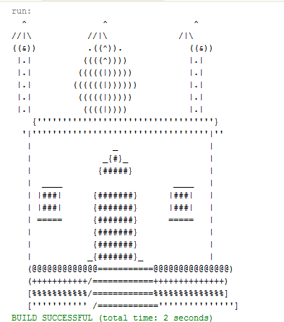  
  
  
  
  
  
  
  
  
  
  
  
  
  
  
  
  
  
  
  
  
SOLUTION:   
 package com.company;  
  
public class Main {  
  
 public static void main(String[] args) {  
 System.*out*.println(" ^ ^ ^");  
 System.*out*.println("//|\\ //^\\ //|\\");  
 System.*out*.println("((@)) (((^))) ((@))");  
 System.*out*.println("||.|| ((((^)))) ||.||");  
 System.*out*.println("||.|| (((((^))))) ||.||");  
 System.*out*.println("||.|| ((((((^)))))) ||.||");  
 System.*out*.println("||.|| (((((((^))))))) ||.||");  
 System.*out*.println("||.|| ((((((((^)))))))) ||.||");  
 System.*out*.println("||.|| (((((((((^))))))))) ||.||");  
 System.*out*.println("||.|| ((((((((((^)))))))))) ||.||");  
 System.*out*.println("||.|| (((((((((((^))))))))))) ||.||");  
 System.*out*.println("{{****************************************}}");  
 System.*out*.println("{|****************************************|}");  
 System.*out*.println("|| ||");  
 System.*out*.println("|| --- ||");  
 System.*out*.println("|| _{#}_ ||");  
 System.*out*.println("|| {###} ||");  
 System.*out*.println("|| _______ {#####} _______ ||");  
 System.*out*.println("|| |#####| {#######} |#####| ||");  
 System.*out*.println("|| |#####| {#######} |#####| ||");  
 System.*out*.println("|| |-----| {#######} |-----| ||");  
 System.*out*.println("|| {#######} ||");  
 System.*out*.println("|| {#######} ||");  
 System.*out*.println("|| {#######} ||");  
 System.*out*.println("|| {#######} ||");  
 System.*out*.println("|| {#######} ||");  
 System.*out*.println("||((((((((((((((\\============\\))))))))))))||");  
 System.*out*.println("||(((((((((((((((\\============\\)))))))))))||");  
 System.*out*.println("||((((((((((((((((\\============\\))))))))))||");  
 System.*out*.println("||(((((((((((((((((\\============\\)))))))))||");  
  
 }  
}

OUTPUT:  
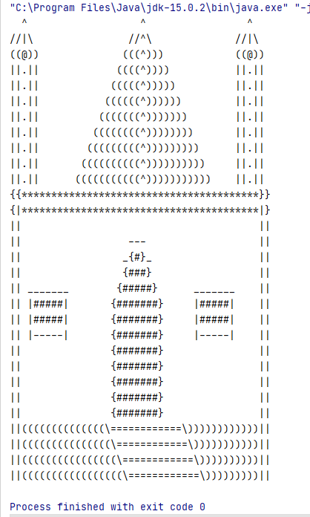  
  
  
  
  
  
  
  
  
  
Task 2: Write a JAVA program, which receives the input of two integer numbers, operation (+, - , *,/,%, power, square-root and factorial) and compute athematic operations. Generate a menu for operations and ask user after every operation if they want to do another. (Hint use switch case)

SOLUTION:   
package com.company;  
import java.util.Scanner;  
import java.lang.Math;  
public class Main {  
 public static void Add()  
 {  
 Scanner input = new Scanner(System.*in*);  
 System.*out*.print("Enter Num 1 : ");  
 int a = input.nextInt();  
 System.*out*.print("Enter Num 2 : ");  
 int b = input.nextInt();  
 System.*out*.println("\n==============");  
 System.*out*.println("Addition = " + (a+b));  
 System.*out*.println("==============");  
 }  
 public static void sub()  
 {  
 Scanner input = new Scanner(System.*in*);  
 System.*out*.print("Enter Num 1 : ");  
 int a = input.nextInt();  
 System.*out*.print("Enter Num 2 : ");  
 int b = input.nextInt();  
 System.*out*.println("\n==================");  
 System.*out*.println("Substraction = " + (a-b));  
 System.*out*.println("==================");  
 }  
 public static void Mul()  
 {  
 Scanner input = new Scanner(System.*in*);  
 System.*out*.print("Enter Num 1 : ");  
 int a = input.nextInt();  
 System.*out*.print("Enter Num 2 : ");  
 int b = input.nextInt();  
 System.*out*.println("\n====================");  
 System.*out*.println("Multiplication = " + (a*b));  
 System.*out*.println("====================");  
 }  
 public static void Divison()  
 {  
 Scanner input = new Scanner(System.*in*);  
 System.*out*.print("Enter Num 1 : ");  
 int a = input.nextInt();  
 System.*out*.print("Enter Num 2 : ");  
 int b = input.nextInt();  
 double ans = (a/b);  
 System.*out*.println("\n==============");  
 System.*out*.println("Division = " + ans);  
 System.*out*.println("==============");  
 }  
 public static void Mod()  
 {  
 Scanner input = new Scanner(System.*in*);  
 System.*out*.print("Enter Num 1 : ");  
 int a = input.nextInt();  
 System.*out*.print("Enter Num 2 : ");  
 int b = input.nextInt();  
 System.*out*.println("\n==============");  
 System.*out*.println("Modulus = " + (a%b));  
 System.*out*.println("==============");  
 }  
 public static void Pow()  
 {  
 Scanner input = new Scanner(System.*in*);  
 System.*out*.print("Enter Num 1 : ");  
 int a = input.nextInt();  
 System.*out*.print("Enter Num 2 : ");  
 int b = input.nextInt();  
 double pow = Math.*pow*(a,b);  
 System.*out*.println("\n==============");  
 System.*out*.println("Power = " + pow);  
 System.*out*.println("==============");  
 }  
 public static void sqrt()  
 {  
 Scanner input = new Scanner(System.*in*);  
 System.*out*.print("Enter Num 1 : ");  
 int a = input.nextInt();  
 double sqrt = Math.*sqrt*(a);  
 System.*out*.println("\n==================");  
 System.*out*.println("Square Root = " + (sqrt));  
 System.*out*.println("==================");  
 }  
 public static void Factorial()  
 {  
 Scanner input = new Scanner(System.*in*);  
 System.*out*.print("Enter Num 1 : ");  
 int a = input.nextInt();  
 int factorial =1;  
 for(int i=a;i>=1;i--)  
 {  
 factorial = factorial*i;  
 }  
 System.*out*.println("\n================");  
 System.*out*.println("Factorial = " + factorial);  
 System.*out*.println("================");  
 }  
 public static Boolean menu()  
 {  
 Scanner input = new Scanner(System.*in*);  
 System.*out*.print("\033[H\033[2J");  
 System.*out*.flush();  
 System.*out*.println("\n~~~~~~~~~~~~");  
 System.*out*.println(" Calculator ");  
 System.*out*.println("~~~~~~~~~~~~");  
 System.*out*.println("Press 1 For Addition ");  
 System.*out*.println("Press 2 For Substraction ");  
 System.*out*.println("Press 3 For Multiplication ");  
 System.*out*.println("Press 4 For Division ");  
 System.*out*.println("Press 5 For Modulus ");  
 System.*out*.println("Press 6 For Power ");  
 System.*out*.println("Press 7 For Square Root ");  
 System.*out*.println("Press 8 For Factorial ");  
 System.*out*.println("Press 9 For Exit ");  
 System.*out*.print("\nChoose An Option : " );  
 int choose = input.nextInt();  
 switch(choose)  
 {  
 case 1:  
 {  
 *Add*();  
 return true;  
 }  
 case 2:  
 {  
 *sub*();  
 return true;  
 }  
 case 3:  
 {  
 *Mul*();  
 return true;  
 }  
 case 4:  
 {  
 *Divison*();  
 return true;  
 }  
 case 5:  
 {  
 *Mod*();  
 return true;  
 }  
 case 6:  
 {  
 *Pow*();  
 return true;  
 }  
 case 7:  
 {  
 *sqrt*();  
 return true;  
 }  
 case 8:  
 {  
 *Factorial*();  
 return true;  
 }  
 case 9:{  
 System.*out*.println("Your Program Is Closed");  
 return false;  
  
 }  
  
 }  
 return true;  
 }  
  
 public static void main(String[] args) {  
 boolean Run = true;  
 while(Run)  
 {  
 Run = *menu*();  
 }  
  
  
 }  
}

OUTPUT:  
  
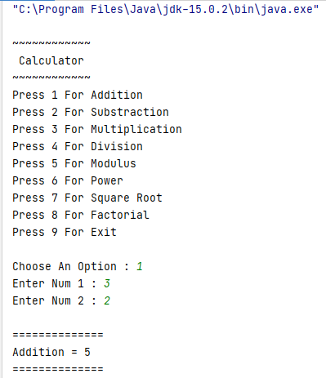  
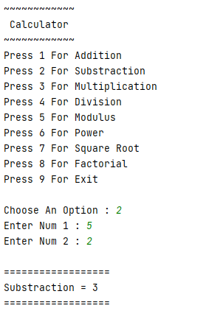  
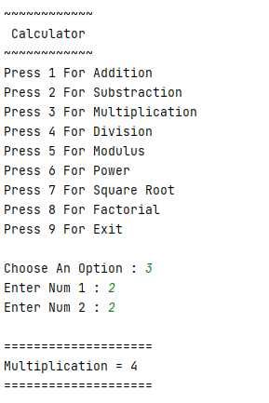  
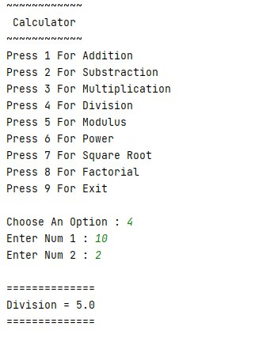  
  
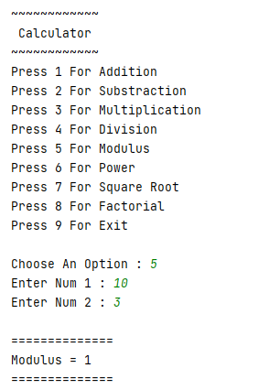  
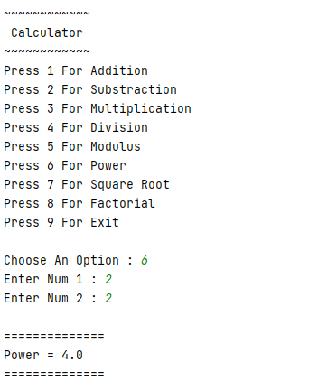  
  
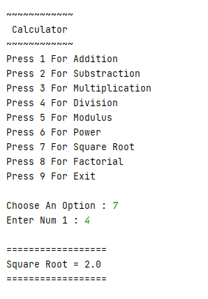  
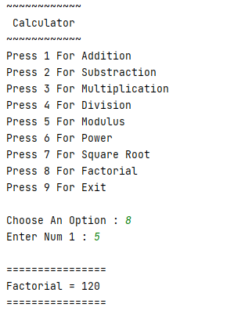  
  
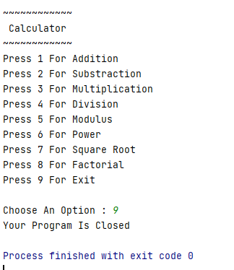  
  
  
  
  
  
Task 3: Make a program in JAVA in which take no. of items, price of items and name of items as input from the user and give the discount according to the following conditions:

1. If from Bahria University give discount of 30%.
2. Else if the total amount is greater than 50,000 and less than 100,000 give discounts of 20%.
3. Else if the total amount is greater than 100,000 give discounts of 30%.

SOLUTION:   
package com.company;  
import java.util.Scanner;  
public class Main {  
  
 public static void main(String[] args) {  
 Scanner Input = new Scanner(System.*in*);  
 System.*out*.print("Enter NO Of Items You Want To Buy(3-5) ");  
 int No = Input.nextInt();  
 String[] name = new String[No];  
 int[] Price = new int[No];  
 for (int i = 0;i < No;i++)  
 {  
 System.*out*.print("Enter Name OF Item : ");  
 name[i] = Input.next();  
 System.*out*.print("Enter Price of Items : ");  
 Price[i] = Input.nextInt();  
 }  
 System.*out*.printf("%-11s %-15s\n", "Name","Price");  
 for(int j = 0;j<No;j++)  
 {  
 System.*out*.printf("%-12s",name[j]);  
 System.*out*.printf("%-25s",Price[j]);  
 System.*out*.print("\n");  
 }  
 double total = 0;  
 for(int k=0;k<No;k++)  
 {  
 total = total + Price[k];  
 }  
 System.*out*.println("\nTotal Amount = " + total);  
 System.*out*.println("\nIf You Are From Bahria Uni You Will Be Given 30% Discount ");  
 System.*out*.println("IF Total Amount b/w 5000 to 10000 You Will Be Given 20% Discount");  
 System.*out*.println("IF Total Amount Greater Than 10000 You Will Be Given 30% Discount");  
 System.*out*.println("\nAre You From Bahria University (Y/N) ");  
 char option = Input.next().charAt(0);  
 double discount = 0;  
 double finalamount = 0;  
 if (option == 'y' || option == 'Y')  
 {  
 discount = total*0.3;  
 finalamount = total-discount;  
 System.*out*.println("Discount amount = " + discount);  
 System.*out*.println("Final Amount = " + finalamount);  
 }  
  
 else if(option == 'n' || option == 'N')  
 {  
 if(total > 5000 && total<10000)  
 {  
 discount = total*0.2;  
 finalamount = total - discount;  
 System.*out*.println("Discount amount = " + discount);  
 System.*out*.println("Final Amount = " + finalamount);  
 }  
 else if(total>10000 )  
 {  
 discount = total*0.3;  
 finalamount = total - discount;  
 System.*out*.println("Discount amount = " + discount);  
 System.*out*.println("Final Amount = " + finalamount);  
 }  
 }  
 }  
}

OUTPUT:  
  
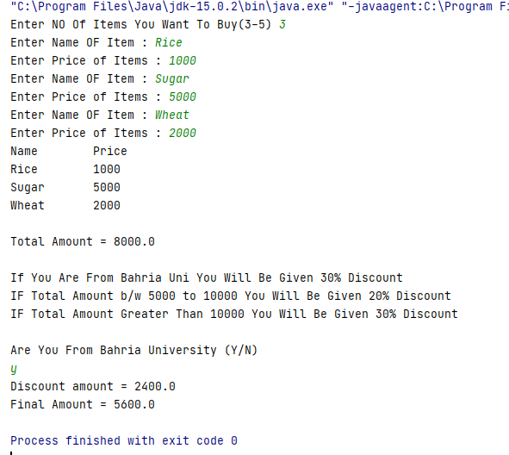  
  
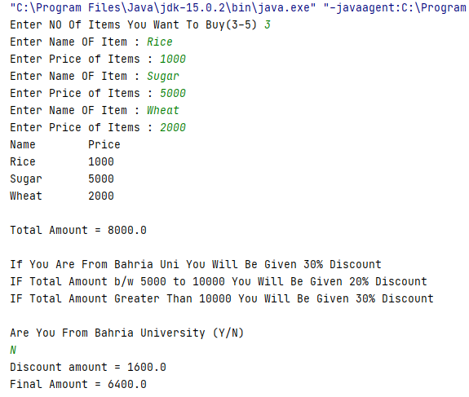  
  
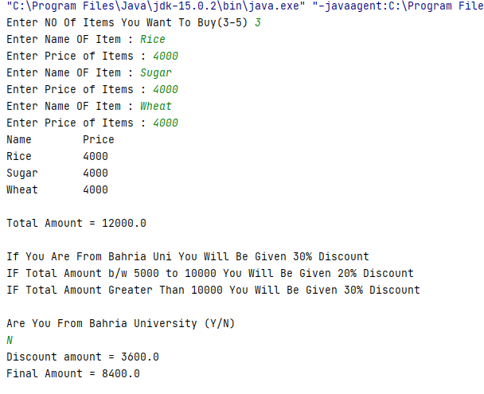  
  
  
  
  
  
  
  
  
  
  
  
  
  
  
  
  
  
  
  
  
  
  
Task 4: Write a JAVA program which will implement the following formulae using methods.

1. Automobile Tire Pressure: P = 0.37m(T + 460)/V P = pressure in psi.

V = volume in cubic feet

m = mass of air in pounds

T = temperature in Fahrenheit

1. Pulley formulas
   1. calculate the speed of one pulley if there are 2 pulleys connected with a belt:

RPM2 = diameter1/diameter2 * RPM1

* 1. calculate the amount of weight that can be lifted with a multiple pulley system:

weight lifted = force exerted * number of up ropes

1. The body mass index (BMI) is a heuristic proxy for human body fat based on an individual's weight and height. BMI does not actually measure the percentage of body fat. We will be building a BMI calculator method. Body mass index (BMI) is computed using the formula,



Where mass is the subject's weight in pounds (lb.) and height is the height in inches (in). The value 703 is a factor to convert BMI to a value that matches the original BMI calculations done in metric units (i.e., kilograms-meters).

SOLUTION:   
  
package com.company;  
import java.util.Scanner;  
public class Main {  
 public static void Automobile()  
 {  
 System.*out*.println("\n======================================");  
 System.*out*.println("Auto Mobile Tire Pressure Calculation ");  
 System.*out*.println("======================================");  
 Scanner Input = new Scanner(System.*in*);  
 System.*out*.print("\nEnter a value of mass of air : ");  
 double m = Input.nextDouble();  
 System.*out*.print("Enter a value of Volume : ");  
 double v = Input.nextDouble();  
 System.*out*.print("Enter a value of Temperature : ");  
 double t = Input.nextDouble();  
 double result = (0.37*m*(t+460)/v);  
 System.*out*.println("\n===================");  
 System.*out*.println("Pressure = " + result );  
 System.*out*.println("===================");  
 }  
 public static void pulley()  
 {  
 Scanner input2 = new Scanner(System.*in*);  
 System.*out*.println("\n=====================");  
 System.*out*.println("Calculation of Pulley ");  
 System.*out*.println("=====================");  
 System.*out*.print("Enter the diameter of first pulley : ");  
 double d1 = input2.nextDouble();  
 System.*out*.print("Enter the speed of first pulley : ");  
 double s1 = input2.nextDouble();  
 System.*out*.print("Enter the diameter of second pulley : ");  
 double d2 = input2.nextDouble();  
 System.*out*.print("\nEnter the total force exerted by the multiple pulley system : ");  
 double FE = input2.nextDouble();  
 System.*out*.print("Enter the total no of rows by the multiple pulley system : ");  
 double NR = input2.nextDouble();  
 double result = (d1/d2)*s1;  
 System.*out*.println("\n============");  
 System.*out*.println(" RPM2 = " + result);  
 System.*out*.println("============");  
 double result1 = (FE*NR);  
 System.*out*.println("\n====================");  
 System.*out*.println("Weight Lifted = " + result1);  
 System.*out*.println("====================");  
 }  
 public static void BMI()  
 {  
 Scanner input3 = new Scanner(System.*in*);  
 System.*out*.println("\n===================");  
 System.*out*.println("Calculation of BMI ");  
 System.*out*.println("===================");  
 System.*out*.print("\nEnter the weight of the body : ");  
 double W = input3.nextDouble();  
 System.*out*.print("Enter the height of the body : ");  
 double H = input3.nextDouble();  
 double Bmi;  
 Bmi = (W/(H*H))*703;  
 System.*out*.println("\n==============");  
 System.*out*.println(" BMI = : " + Bmi);  
 System.*out*.println("==============");  
  
 }  
 public static void main(String[] args) {  
 *Automobile*();  
 *pulley*();  
 *BMI*();  
 }  
  
}

OUTPUT:  
  
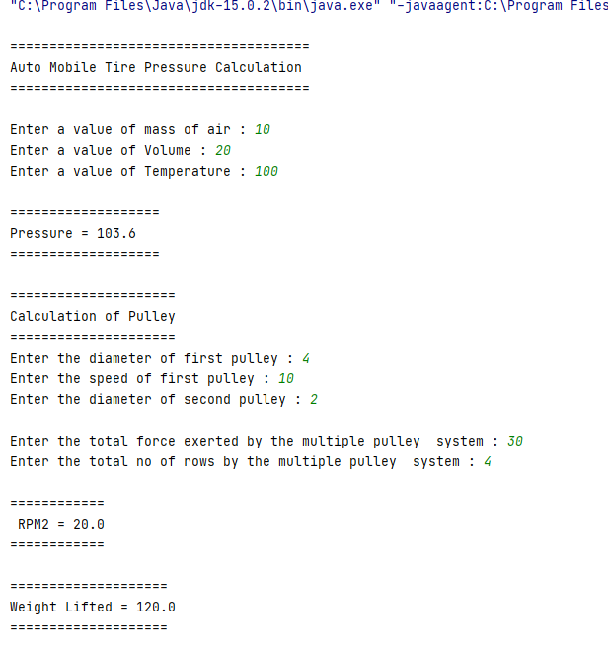  
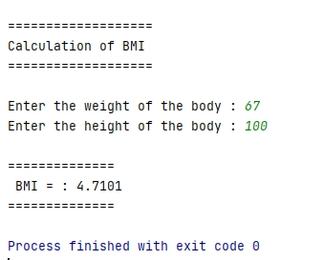  
  
  
  
  
  
  
  
  
  
  
  
  
  
  
  
  
  
  
  
  
  
  
  
  
  
  
  
  
  
  
  
  
  
  
  
  
  
  
 Bahria University,

Karachi Campus



LAB EXPERIMENT NO.

02

LIST OF TASKS

|  |  |
| --- | --- |
| TASK NO | OBJECTIVE |
| 01 | Create a class student which contains the basic data about the student that takes the basic student data and displays it by using display method. An option of update is being provided to the user if he/she want to update the data, the required data being updated. |
| 02 | Create a class “computer” which contains specifications of computer, the program shall ask the user does he/she wants to open the system, if the user press “yes” then the system starts shows the initial loading and then displays the basic configuration of a system (by calling the method of display () ), update option is being provided by the user, values of the specified items are being updated once user decides to update that item. |
| 03 | Create a class of Employee which contains basic information about an employee, employee name, father’s name and salary etc. are being displayed by the display method and the salary of employees or the designation of the employees are being set/updated as per need. |
| 04 | . Create a class of Automobile which contains specifications of a car, check whether the car is in - ON/start state if not them asks the user if he/she want to start the car, If the car is already in start state then first display the current status of the car which includes the horse power, color, made, engine type etc. providing an option to the user if he/she wants to update any of the mentioned part from the car, if user selects “YES” then it is updated according to the need of the user, else the program will be ended. |
| 05 | Implement a class Car, that has the following characteristics:  a) Brand name  b) Price New, which represents the price of the car when it was new  c) Color and  d) Odometer, which is milo meter shows number of milage travelled by car  The class should have:  A. A method getPriceAfterUse () which should return the price of the car after being used according to the following formula: car price after being used=price New*(1-(odometer/600,00))  B. A method updateMilage (double travelled distance) that changes the current state of the car by increasing its milage, and   1. A method output Details () that will output to the screen all the information of the car, i.e. brand name, price New, price used, color and odometer. |
|  |  |

**Task No: 01 Create a class student which contains the basic data about the student that takes the basic student data and displays it by using display method. An option of update is being provided to the user if he/she want to update the data, the required data being updated.  
  
Solution:  
 Student Class:**package com.company;  
import java.util.Scanner;  
import java.lang.String;  
public class Student  
{  
 String[][] record = {  
 {"","","",""},  
 {"","","",""},  
 {"","","",""},  
 {"","","",""},  
 {"","","",""}  
 };  
 public void input()  
 {  
 Scanner input = new Scanner(System.*in*);  
  
 for(int i = 0;i<5;i++)  
 {  
 System.*out*.println();  
 System.*out*.print("Enter Name : ");  
 record[i][0] = input.next();  
 System.*out*.print("Enter Enrollment Num : ");  
 record[i][1] = input.next();  
 System.*out*.print("Enter Semester : ");  
 record[i][2] = input.next();  
 System.*out*.print("Enter Course : ");  
 record[i][3] = input.next();  
 }  
 }  
 public void display()  
 {  
 System.*out*.printf("%60s\n","~~~~~~~~~~~~~~~~~~");  
 System.*out*.printf("%60s\n","Students Records");  
 System.*out*.printf("%60s\n","~~~~~~~~~~~~~~~~~~");  
 System.*out*.printf("%20s %20s %20s %20s\n", "Name","Enrollment","Semester","Course");  
 for (int j=0;j<5;j++)  
 {  
 for (int k=0;k<4;k++)  
 {  
 System.*out*.printf("%20s " , record[j][k]);  
 }  
 System.*out*.println();  
 }  
 System.*out*.println();  
 }  
 public void update()  
 {  
 Scanner input = new Scanner(System.*in*);  
 System.*out*.println("\nFOR UPDATION");  
 System.*out*.println("Press 1 For Update Name ");  
 System.*out*.println("Press 2 For Update Enrollment ");  
 System.*out*.println("Press 3 For Update Semester ");  
 System.*out*.println("Press 4 For Update Course ");  
 System.*out*.print("Select Anyone : ");  
 int a = input.nextInt();  
 switch (a)  
 {  
 case 1:  
 System.*out*.print("\nEnter Row Num : ");  
 int row = input.nextInt();  
 System.*out*.print("Enter Name : ");  
 record[row][0] = input.next();  
 break;  
 case 2:  
 System.*out*.print("\nEnter Row Num : ");  
 int b = input.nextInt();  
 System.*out*.print("Enter Enrollment : ");  
 record[b][1] = input.next();  
 break;  
 case 3:  
 System.*out*.print("\nEnter Row Num : ");  
 int c = input.nextInt();  
 System.*out*.print("Enter Semester : ");  
 record[c][2] = input.next();  
 break;  
 case 4:  
 System.*out*.print("\nEnter Row Num : ");  
 int d = input.nextInt();  
 System.*out*.print("Enter Course : ");  
 record[d][3] = input.next();  
 break;  
 default:  
 System.*out*.println("\nOut Of Filed...!!!!");  
 break;  
 }  
  
 }  
}

**Main:**package com.company;  
import java.util.Scanner;  
import java.lang.String;  
public class Main  
{  
 public static void main(String[] args)  
 {  
 Student obj = new Student();  
 Scanner input = new Scanner(System.*in*);  
 System.*out*.printf("%40s","Enter Students Information");  
 obj.input();  
 System.*out*.print("\nYou Want to Display Record?? (Y/N) : ");  
 char select = input.next().charAt(0);  
 boolean t = true;  
 if(select == 'y' || select == 'Y')  
 {  
 while (t)  
 {  
 obj.display();  
 System.*out*.print("\nYou Want To Update Record Of Any Student?? (Y/N) : ");  
 char value = input.next().charAt(0);  
 if(value == 'y' || value == 'Y')  
 {  
 obj.update();  
 }  
 else if(value == 'n' || value == 'N')  
 {  
 System.*out*.println("\nGood Bye......");  
 t = false;  
 }  
  
 }  
 }  
 else {  
 System.*out*.println("\nGood Bye......");  
 t = false;  
  
 }  
  
  
  
  
  
  
  
  
  
 }  
}

**Output: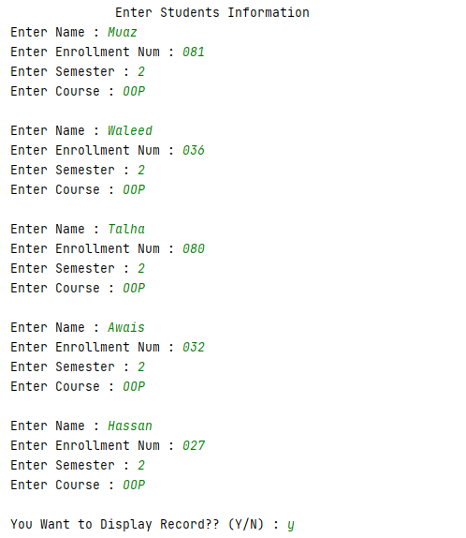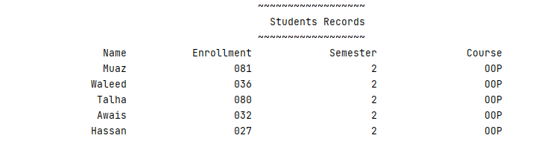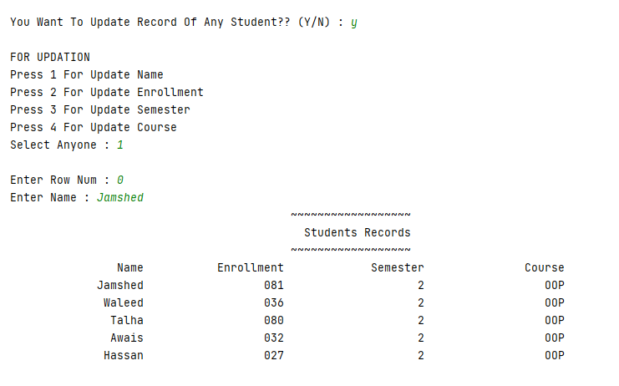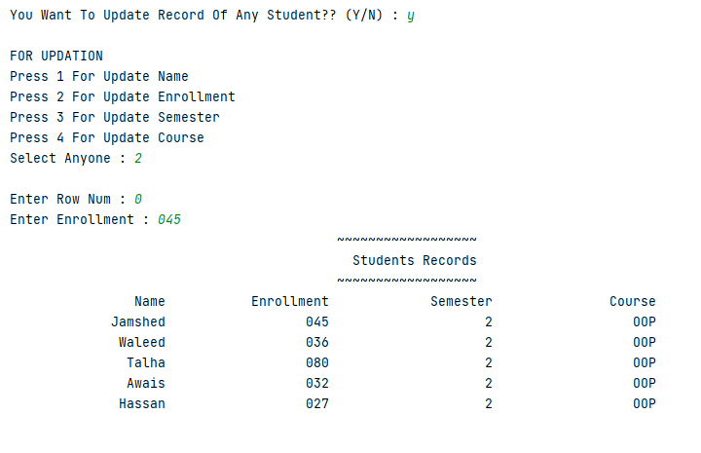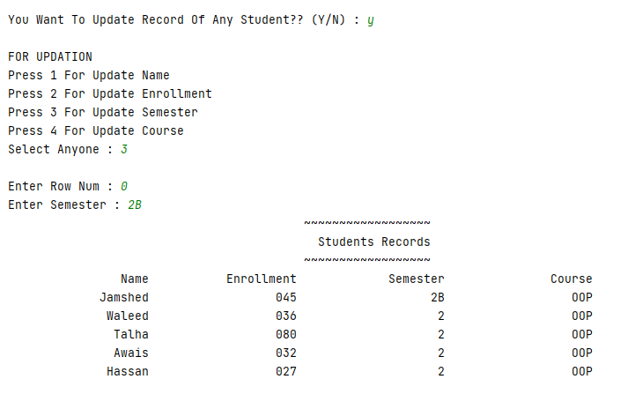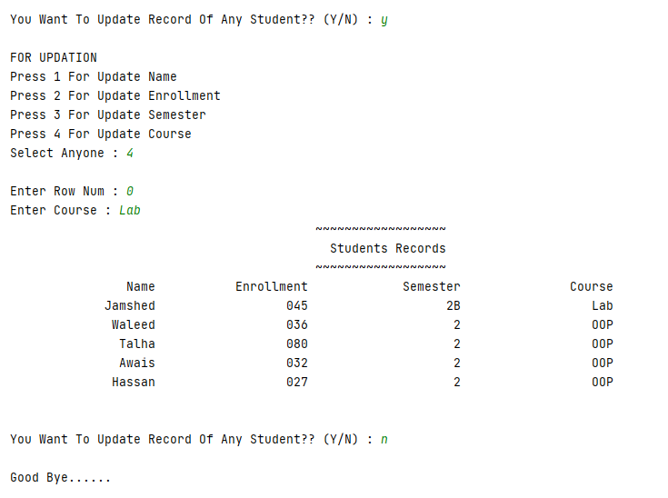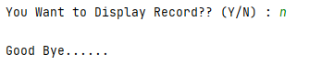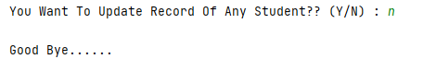 Task No: 02 Create a class “computer” which contains specifications of computer, the program shall ask the user does he/she wants to open the system, if the user press “yes” then the system starts shows the initial loading and then displays the basic configuration of a system (by calling the method of display () ), update option is being provided by the user, values of the specified items are being updated once user decides to update that item.**

**Solution:  
 Computer Class:**package com.company;  
import java.util.Scanner;  
public class Computer  
{  
 String[][] Specs = {{"","","","",""}};  
 public void Specification()  
 {  
 Specs[0][0] = "i7";  
 Specs[0][1] = "4th";  
 Specs[0][2] = "8";  
 Specs[0][3] = "500GB";  
 Specs[0][4] = "10";  
 }  
 public void display()  
 {  
 System.*out*.printf("\n%60s\n"," Specifications....");  
 System.*out*.printf("\n%20s %19s %20s %19s %20s\n", "PC","Generation","RAM/GB","HardDisk","Window");  
 for (int i=0;i<5;i++)  
 {  
 System.*out*.printf("%20s",Specs[0][i]);  
 }  
 }  
 public void update()  
 {  
 Scanner input = new Scanner(System.*in*);  
 System.*out*.println("\nFOR UPDATION");  
 System.*out*.println("Press 1 For Update PC ");  
 System.*out*.println("Press 2 For Update Generation ");  
 System.*out*.println("Press 3 For Update RAM ");  
 System.*out*.println("Press 4 For Update HardDisk ");  
 System.*out*.println("Press 5 For Update Window ");  
 System.*out*.print("Select Anyone : ");  
 int a = input.nextInt();  
 switch (a)  
 {  
 case 1:  
 System.*out*.print("\nEnter New PC : ");  
 Specs[0][0] = input.next();  
 break;  
 case 2:  
 System.*out*.print("\nEnter New Generation : ");  
 Specs[0][1] = input.next();  
 break;  
 case 3:  
 System.*out*.print("\nEnter New RAM : ");  
 Specs[0][2] = input.next();  
 break;  
 case 4:  
 System.*out*.print("\nEnter New HardDisk : ");  
 Specs[0][3] = input.next();  
 break;  
 case 5:  
 System.*out*.print("\nEnter New Window : ");  
 Specs[0][4] = input.next();  
 break;  
 default:  
 System.*out*.println("\nOut Of Filed..!!!");  
 break;  
 }  
 }  
}

**Main:**package com.company;  
import java.util.Scanner;  
public class Main  
{

public static void main(String[] args)  
 {  
 Scanner input = new Scanner(System.*in*);  
 Computer obj = new Computer();  
 System.*out*.print("\nYou Want To Start System??(Y/N) : ");  
 char slct = input.next().charAt(0);  
 boolean system = true;  
 if(slct == 'y'||slct=='Y')  
 {  
 obj.Specification();  
 obj.display();  
 while (system)  
 {  
 System.*out*.print("\n\nYou Want to Update System?? (Y/N) : ");  
 char selct = input.next().charAt(0);  
 if(selct == 'y'||selct=='Y')  
 {  
 obj.update();  
 obj.display();  
 }  
 else if(selct == 'n'||selct=='N')  
 {  
 System.*out*.print("\nYou Want To Shut Down??(Y/N) : ");  
 char select = input.next().charAt(0);  
 if(select == 'y'||select=='Y')  
 {  
 System.*out*.println("\n~~~~~~~~~~~~~~~~~~");  
 System.*out*.println("Shut Down....!!!");  
 System.*out*.println("~~~~~~~~~~~~~~~~~~");  
 system = false;  
 }  
  
 }  
 }  
  
 }  
 else {  
 System.*out*.println("\n~~~~~~~~~~~~~~~~~~~~~~~~~~~~~~~");  
 System.*out*.println("Your System Is Still Shut Down");  
 System.*out*.println("~~~~~~~~~~~~~~~~~~~~~~~~~~~~~~~");  
  
 }  
  
  
 }  
}

**Output:**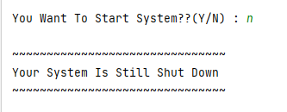

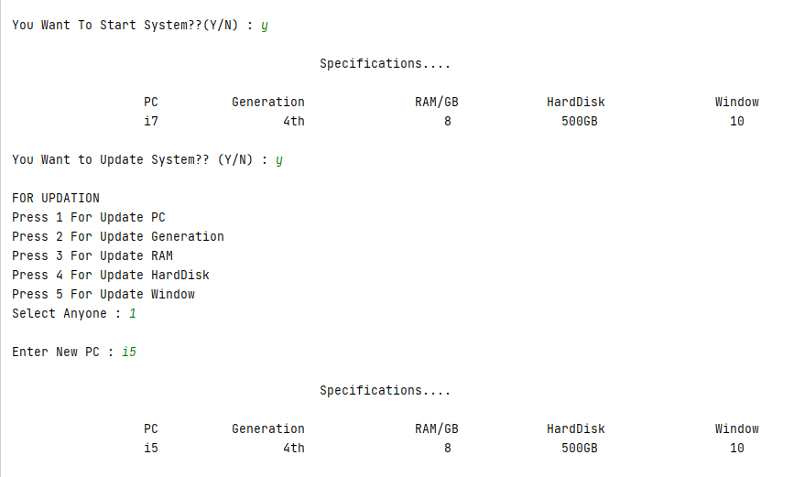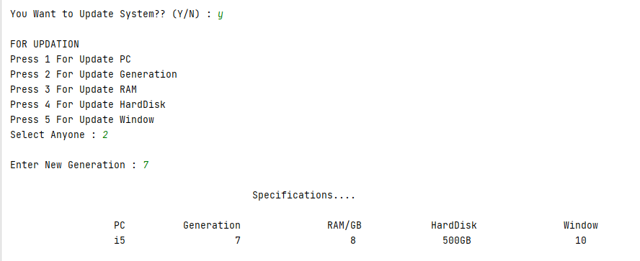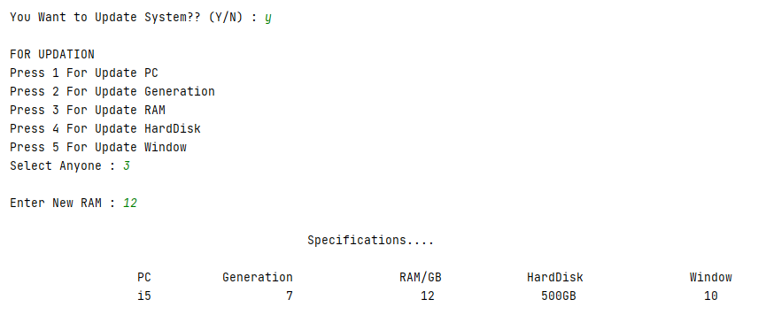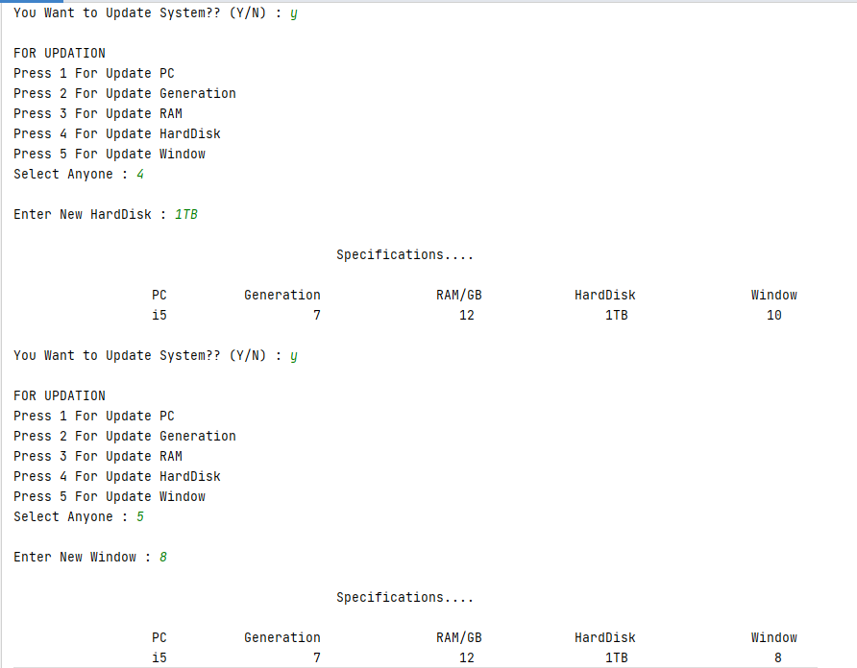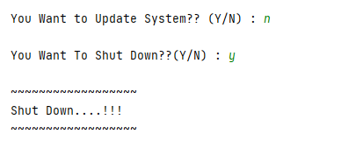

**Task No: 03 Create a class of Employee which contains basic information about an employee, employee name, father’s name and salary etc. are being displayed by the display method and the salary of employees or the designation of the employees are being set/updated as per need.**

**Solution:  
 Employee Class:**package com.company;  
import java.util.Scanner;  
public class Employee  
{  
 String[][] employe = {  
 {"","","","",""},  
 {"","","","",""},  
 {"","","","",""},  
 };  
 public void input()  
 {  
 Scanner input = new Scanner(System.*in*);  
 for(int i = 0;i<3;i++)  
 {  
 System.*out*.print("\nEmploye Id : ");  
 employe[i][0] = input.next();  
 System.*out*.print("Name : ");  
 employe[i][1] = input.next();  
 System.*out*.print("Father Name : ");  
 employe[i][2] = input.next();  
 System.*out*.print("Designation : ");  
 employe[i][3] = input.next();  
 System.*out*.print("Salary : ");  
 employe[i][4] = input.next();  
 }  
 }  
 public void display()  
 {  
  
 System.*out*.printf("%55s\n","Employee's Information ");  
 System.*out*.printf("\n%20s %20s %20s %17s %20s\n", "Id","Name","Father Name","Designation","Salary");  
 for (int j=0;j<3;j++)  
 {  
 for (int k=0;k<5;k++)  
 {  
 System.*out*.printf("%20s",employe[j][k]);  
 }  
 System.*out*.println();  
 }  
 System.*out*.println();  
 }  
 public void update()  
 {  
 Scanner input = new Scanner(System.*in*);  
 System.*out*.println("\nFOR UPDATION");  
 System.*out*.println("Press 1 For Update Designation ");  
 System.*out*.println("Press 2 For Update Salary ");  
 System.*out*.print("Select Anyone : ");  
 int a = input.nextInt();  
 switch (a)  
 {  
 case 1:  
 System.*out*.print("\nEnter Row Num : ");  
 int row = input.nextInt();  
 System.*out*.print("Enter Designation : ");  
 employe[row][3] = input.next();  
 break;  
 case 2:  
 System.*out*.print("\nEnter Row Num : ");  
 int b = input.nextInt();  
 System.*out*.print("Enter Salary : ");  
 employe[b][4] = input.next();  
 break;  
 default:  
 System.*out*.println("\nOut Of Filed...!!!!");  
 break;  
 }  
  
 }  
}

**Main:**package com.company;  
  
import java.util.Scanner;  
  
public class Main  
{  
  
 public static void main(String[] args)  
 {  
 Scanner user = new Scanner(System.*in*);  
 Employee obj = new Employee();  
 System.*out*.printf("\n%30s\n","Enter Employee Informatiion ");  
 obj.input();  
 obj.display();  
 boolean t = true;  
 while (t)  
 {  
 System.*out*.print("\nYou Want To Update Employe Info?? (Y/N) : ");  
 char op = user.next().charAt(0);  
 if(op == 'y'||op == 'Y')  
 {  
 obj.update();  
 obj.display();  
 }  
 else if(op == 'n'||op == 'N'){  
 System.*out*.print("\nYou Want To Close Program?? (Y/N) : ");  
 char opt = user.next().charAt(0);  
 if(opt == 'y'||opt == 'Y')  
 {  
 System.*out*.println("\nClosed...!!");  
 t = false;  
 }  
 else {  
 t = true;  
 }  
  
 }  
  
 }  
  
 }  
}

**Output:**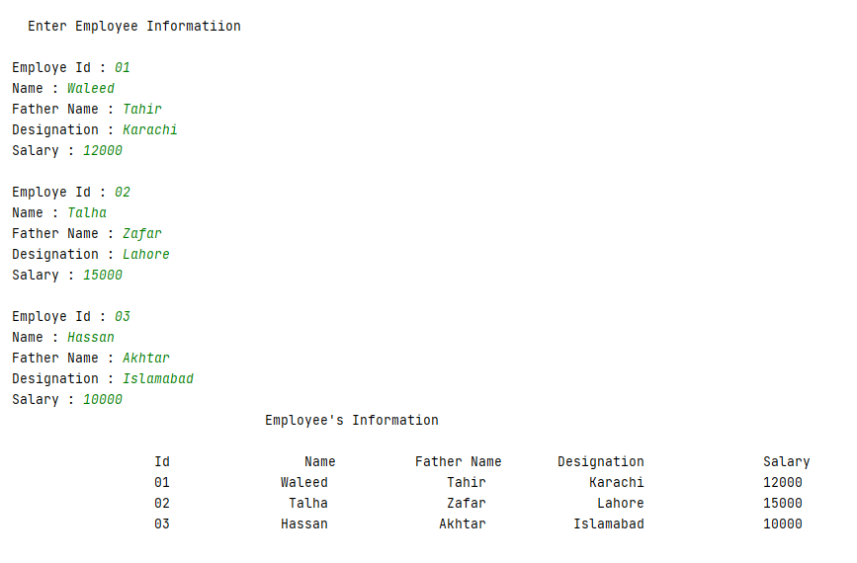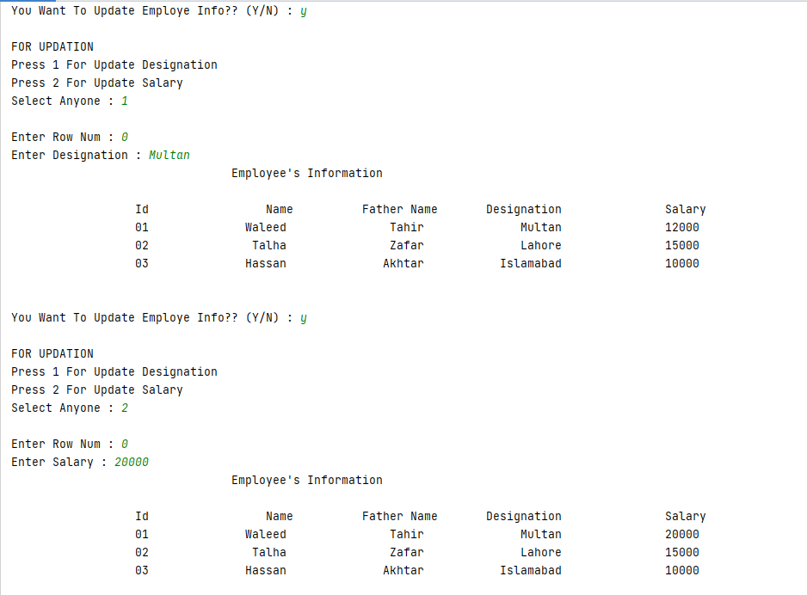

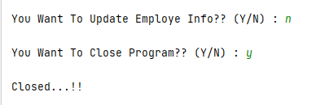 **Task No: 04.** **Create a class of Automobile which contains specifications of a car, check whether the car is in - ON/start state if not them asks the user if he/she want to start the car, If the car is already in start state then first display the current status of the car which includes the horse power, color, made, engine type etc. providing an option to the user if he/she wants to update any of the mentioned part from the car, if user selects “YES” then it is updated according to the need of the user, else the program will be ended.  
  
Solution:  
 Automobile Class:**package com.company;  
import java.util.Scanner;  
public class Automobile  
{  
 String[][] auto = {{"","","","",""}};  
 public void details()  
 {  
 auto[0][0] = "2500cc";  
 auto[0][1] = "Black";  
 auto[0][2] = "2020";  
 auto[0][3] = "3000000";  
 auto[0][4] = "Japan";  
 }  
 public void Display()  
 {  
 System.*out*.printf("\n%50s\n","Specifications....");  
 System.*out*.printf("\n%20s %20s %19s %17s %20s\n", "HorsePower","Colour","Model","Price","Made By");  
 for (int i=0;i<5;i++)  
 {  
 System.*out*.printf("%20s",auto[0][i]);  
 }  
 }  
 public void update()  
 {  
 Scanner input = new Scanner(System.*in*);  
 System.*out*.println("\nFOR UPDATION");  
 System.*out*.println("Press 1 For Update HorsePower ");  
 System.*out*.println("Press 2 For Update Color ");  
 System.*out*.println("Press 3 For Update Model ");  
 System.*out*.println("Press 4 For Update Price ");  
 System.*out*.println("Press 5 For Update Made By ");  
 System.*out*.print("Select Anyone : ");  
 int a = input.nextInt();  
 switch (a)  
 {  
 case 1:  
 System.*out*.print("\nEnter New HorsePower : ");  
 auto[0][0] = input.next();  
 break;  
 case 2:  
 System.*out*.print("\nEnter New Color : ");  
 auto[0][1] = input.next();  
 break;  
 case 3:  
 System.*out*.print("\nEnter New Model : ");  
 auto[0][2] = input.next();  
 break;  
 case 4:  
 System.*out*.print("\nEnter New Price : ");  
 auto[0][3] = input.next();  
 break;  
 case 5:  
 System.*out*.print("\nEnter New Made By : ");  
 auto[0][4] = input.next();  
 break;  
 default:  
 System.*out*.println("\nOut Of Filed..!!!");  
 break;  
 }  
  
 }  
}

**Main:**package com.company;  
import java.util.Scanner;  
public class Main  
{  
  
 public static void main(String[] args)  
 {  
 Scanner input = new Scanner(System.*in*);  
 Automobile obj = new Automobile();  
 System.*out*.println("\nFor Display Details Of Car First Check State Of Car ");  
 System.*out*.print("\nFirst You Check The Car State (Y/N) : ");  
 char op = input.next().charAt(0);  
 boolean t = true;  
 boolean tru = true;  
 if (op == 'y'||op == 'Y')  
 {  
 System.*out*.printf("\n%50s\n","Car Is In Start State ");  
 obj.details();  
 obj.Display();  
 while (t){  
 System.*out*.print("\n\nYou Want To Update Automobile Info?? (Y/N) : ");  
 char opt = input.next().charAt(0);  
 if(opt == 'y'||opt == 'Y')  
 {  
 obj.update();  
 obj.Display();  
 }  
 else if(opt == 'n'||opt == 'N'){  
 System.*out*.print("\nYou want to Close Program??(Y/N) : ");  
 char optn = input.next().charAt(0);  
 if(optn == 'y'||optn == 'Y')  
 {  
 System.*out*.println("\nClosed...!!");  
 t = false;  
 }  
 else {  
 t = true;  
 }  
  
 }  
 }  
  
  
 }  
 else if (op == 'n'||op == 'N')  
 {  
 System.*out*.printf("\n%50s\n","Car Is In Off State ");  
 System.*out*.print("\nYou Want To Start The Car??(Y/N) : ");  
 char optns = input.next().charAt(0);  
 if(optns == 'y'||optns == 'Y')  
 {  
 System.*out*.printf("\n%50s\n","Now Car Is In Start State ");  
 obj.details();  
 obj.Display();  
 while (tru)  
 {  
 System.*out*.print("\nYou Want To Update Automobile Info?? (Y/N) : ");  
 char user = input.next().charAt(0);  
 if(user == 'y'||user == 'Y')  
 {  
 obj.update();  
 obj.Display();  
 }  
 else if(user == 'n'||user == 'N'){  
 System.*out*.print("\nYou want to Close Program??(Y/N) : ");  
 char users = input.next().charAt(0);  
 if(users == 'y'||users == 'Y')  
 {  
 System.*out*.println("\n~~~~~~~~~~");  
 System.*out*.println("Closed...!!");  
 System.*out*.println("~~~~~~~~~~~");  
 tru = false;  
 }  
 else {  
 tru = true;  
 }  
 }  
  
  
 }  
 }  
 else {  
 System.*out*.print("\nOk..!! Program Is Closed..");  
  
  
 }  
  
 }  
 else {  
 System.*out*.println("\nWrong Input");  
 System.*out*.println("Your Program Is Closed Start Again...!!");  
 }  
  
 }  
}

**Output:**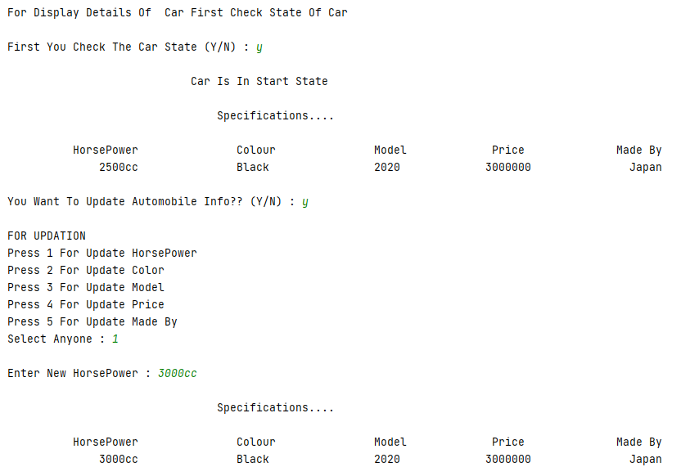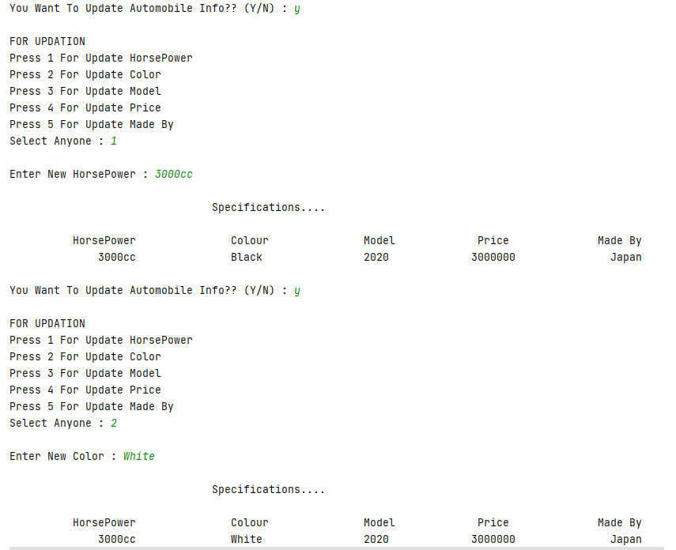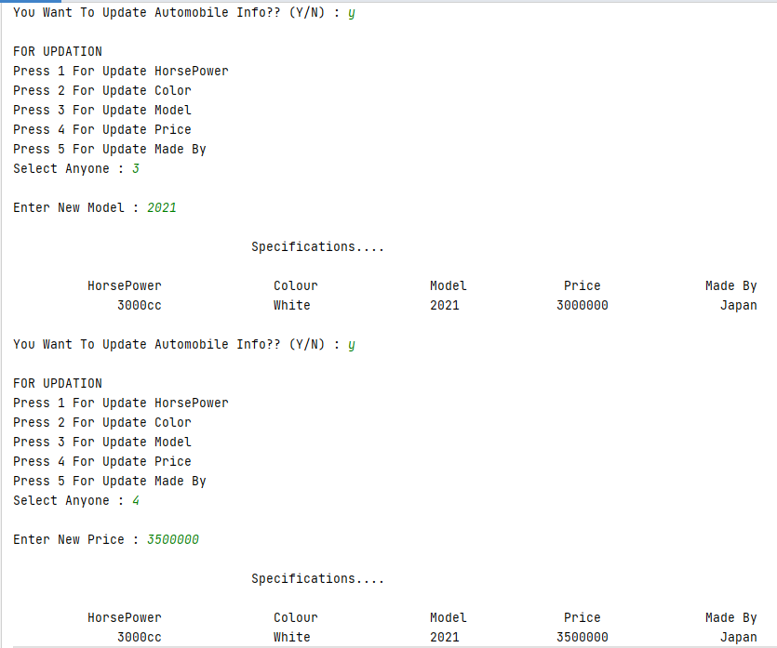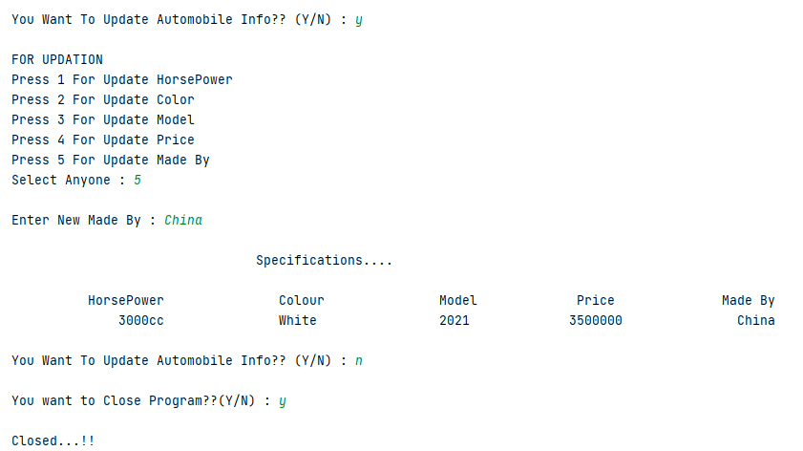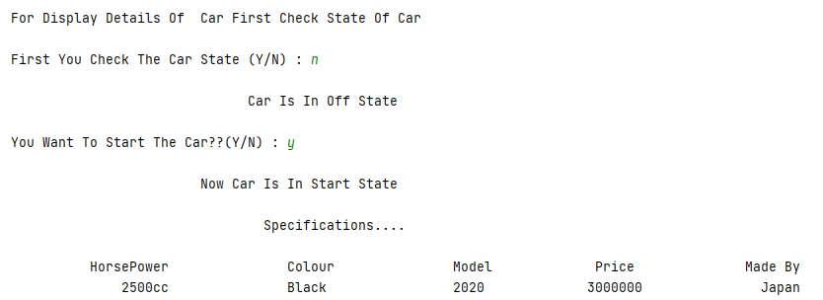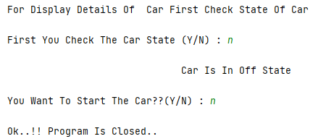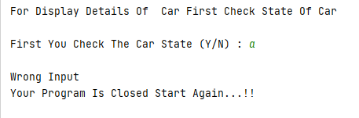

**Task No: 05 Implement a class Car, that has the following characteristics:**

**a) Brand name**

**b) Price New, which represents the price of the car when it was new**

**c) Color and**

**d) Odometer, which is milo meter shows number of milage travelled by car**

**The class should have:**

**A. A method getPriceAfterUse () which should return the price of the car after being used according to the following formula: car price after being used=price New*(1-(odometer/600,00))**

**B. A method updateMilage (double travelled distance) that changes the current state of the car by increasing its milage, and**

1. **A method output Details () that will output to the screen all the information of the car, i.e. brand name, priceNew,price used, color and odometer.**

**Solution:  
 Car Class:**package com.company;  
import java.util.Scanner;  
public class Car  
{  
 String BrandName = "Mercedes";  
 double PriceNew = 150000;  
 String Colour = "Black";  
 double Odometer = 00;  
 double used;  
 public void Details()  
 {  
 System.*out*.println("\nBrand : Mercedes");  
 System.*out*.println("PriceNew : 150000");  
 System.*out*.println("Colour : Black");  
 System.*out*.println("Odometer : 00");  
 }  
 public void Updatemillage()  
 {  
 Scanner input = new Scanner(System.*in*);  
 System.*out*.print("\nEnter New Millage : ");  
 Odometer = input.nextDouble();  
 }  
 public void getafteruse()  
 {  
 used = PriceNew*(1-(Odometer/60000));  
 }  
 public void OutputDisplay()  
 {  
 System.*out*.println("\nBrand : Mercedes");  
 System.*out*.println("PriceNew : 150000");  
 System.*out*.println("Price After Used Car : " + used);  
 System.*out*.println("Colour : Black");  
 System.*out*.println("Odometer : " + Odometer);  
 }  
}

**Main:**package com.company;  
import java.lang.String;  
public class Main  
{  
 public static void main(String[] args)  
 {  
  
 Car obj = new Car();  
 System.*out*.printf("\n%40s","Car Properties");  
 obj.Details();  
 obj.Updatemillage();  
 obj.getafteruse();  
 obj.OutputDisplay();  
 }  
  
}

**Output:**

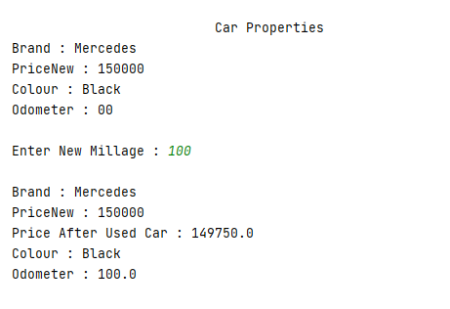

Bahria University,

Karachi Campus



LAB EXPERIMENT NO.

**03**

LIST OF TASKS

|  |  |
| --- | --- |
| TASK NO | OBJECTIVE |
| 01 | Consider a computer system whose name, type, processor specification, ram, hard disk drives, mother board, optical drive etc. are its member variables and its desired values that cannot be accessed directly. They are entered by the user in a get method (that takes information from the user) and the displays the inputted information via display method. The user shall be asked to change any of the provided information if he/she agrees to change the information then new values shall be asked from the user. |
| 02 | Write a program to display the radius and color of a circle in Java. Use private Access modifiers for member variables of circle class and accessor and mutator methods to get and set the member values. |
| 03 | Implement a class *Car,* that has the following characteristics and should be implemented using proper access modifier: A method *getPriceAfterUse()* which should return the price of the car after being used according to the following formula: car price after being used = *price New* () A method *undermanage(double traveled Distance)* that changes the current state of the car by increasing its milage, and A method *output Details()* that will output to the screen all the information of the car, |
| 04 | Write a program to display students name, age, University name and Semester for all 3 students where all students belong to same university and Semester initially. If the student belongs to any other University, then the required method should be called to change his/her University. |

**Task No: 1 Consider a computer system whose name, type, processor specification, ram, hard disk drives, mother board, optical drive etc. are its member variables and its desired values that cannot be accessed directly. They are entered by the user in a get method (that takes information from the user) and the displays the inputted information via display method. The user shall be asked to change any of the provided information if he/she agrees to change the information then new values shall be asked from the user.  
  
Solution:  
Class:**package com.company;  
import java.util.Scanner;  
import java.lang.String;  
public class Compsys  
{  
 private String name;  
 private String processor;  
 private String Harddisk;  
 private String Generation;  
 private String Ram;  
 public void setn(String name)  
 {  
 this.name = name;  
 }  
 public void setp(String processor)  
 {  
 this.processor = processor;  
 }  
 public void seth(String Harddisk)  
 {  
 this.Harddisk = Harddisk;  
 }  
 public void setg(String Generation)  
 {  
 this.Generation = Generation;  
 }  
 public void setr(String Ram)  
 {  
 this.Ram = Ram;  
 }  
 public void display()  
 {  
 System.*out*.println("\n#############Display#############");  
 System.*out*.println("| Name : " + name);  
 System.*out*.println("| Processor : " + processor);  
 System.*out*.println("| HardDisk : " + Harddisk);  
 System.*out*.println("| Generation : " + Generation);  
 System.*out*.println("| Ram : " + Ram);  
 System.*out*.println("#################################");  
 }  
 public void update()  
 {  
 Scanner input = new Scanner(System.*in*);  
 System.*out*.println("\n############Update Menu############");  
 System.*out*.println("Press 1 For Update Name");  
 System.*out*.println("Press 2 For Update Processor");  
 System.*out*.println("Press 3 For Update Ram");  
 System.*out*.println("Press 4 For Update Generation");  
 System.*out*.println("Press 5 For Update HardDisk");  
 System.*out*.println("#################################");  
 System.*out*.print("\nSelect One : ");  
 int a = input.nextInt();  
 switch (a)  
 {  
 case 1:  
 System.*out*.print("Enter Name : ");  
 setn(input.next());  
 break;  
 case 2:  
 System.*out*.print("Enter Processor : ");  
 setp(input.next());  
 break;  
 case 3:  
 System.*out*.print("Enter Ram : ");  
 setr(input.next());  
 break;  
 case 4:  
 System.*out*.print("Enter Generation : ");  
 setg(input.next());  
 break;  
 case 5:  
 System.*out*.print("Enter HardDisk : ");  
 seth(input.next());  
 break;  
 default:  
 System.*out*.print("Please Enter Valid Input...");  
 break;  
 }  
  
 }  
}

**Main:**package com.company;  
import java.util.Scanner;  
public class Main  
{  
  
 public static void main(String[] args)  
 {  
 Scanner input = new Scanner(System.*in*);  
 Compsys obj = new Compsys();  
 System.*out*.print("Enter PC Name : ");  
 obj.setn(input.next());  
 System.*out*.print("Enter Processor : ");  
 obj.setp(input.next());  
 System.*out*.print("Enter Ram : ");  
 obj.setr(input.next());  
 System.*out*.print("Enter Generation : ");  
 obj.setg(input.next());  
 System.*out*.print("Enter HardDisk : ");  
 obj.seth(input.next());  
 boolean t = true;  
 while (t)  
 {  
 obj.display();  
 System.*out*.print("\nYou Want To Update Any Inforamtion??? (Y/N) : ");  
 char optn = input.next().toUpperCase().charAt(0);  
 switch (optn)  
 {  
 case 'Y':  
 obj.update();  
 break;  
 case 'N':  
 System.*out*.print("\nYou Want To Exit From Program???(Y/N) : ");  
 char choice = input.next().toUpperCase().charAt(0);  
 if(choice == 'Y')  
 {  
 System.*out*.println("\n Good Bye...!!! ");  
 System.*exit*(0);  
 }  
 else {  
 t = true;  
 }  
 break;  
 default:  
 System.*out*.println("Please Enter Valid Input....");  
 t = true;  
  
 }  
  
 }  
  
  
  
 }  
}

**Output: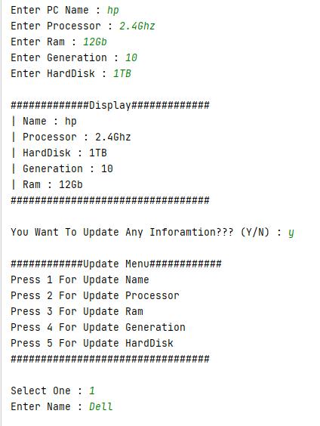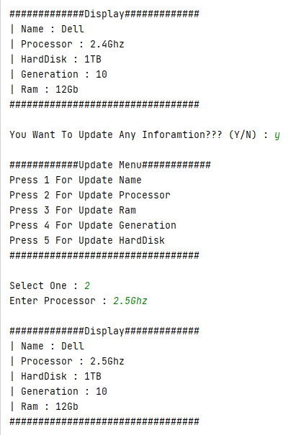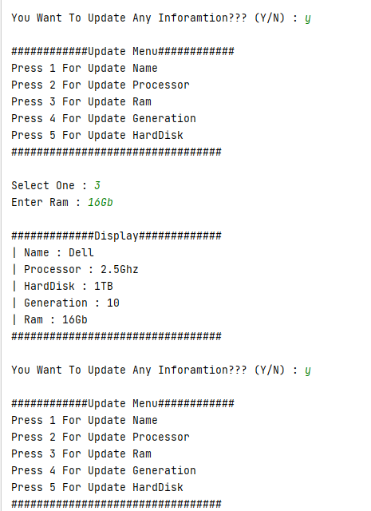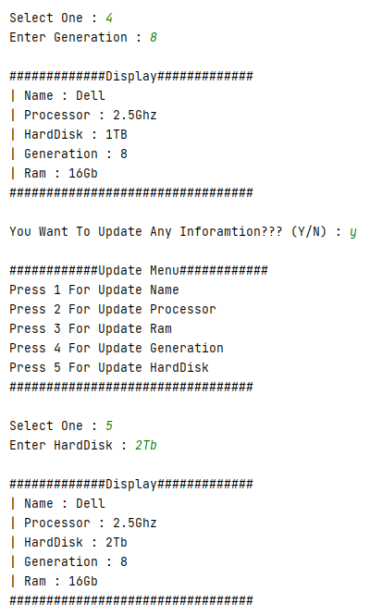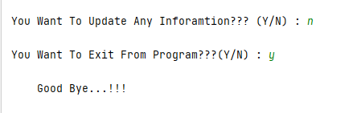 Task No: 2 Write a program to display the radius and colour of a circle in Java. Use private Access modifiers for member variables of circle class and accessor and mutator methods to get and set the member values.  
  
Solution:  
Class:**package com.company;  
  
public class Colorradius  
{  
 private String radius;  
 private String color;  
 public void setColor(String color)  
 {  
 this.color = color;  
 }  
 public void setRadius(String radius)  
 {  
 this.radius = radius;  
 }  
 public String getColor()  
 {  
 return color;  
 }  
 public String getRadius()  
 {  
 return radius;  
 }  
}

**Main:**package com.company;  
  
public class Main  
{  
  
 public static void main(String[] args)  
 {  
 Colorradius obj = new Colorradius();  
 System.*out*.print("\nColor Of Circle : ");  
 obj.setColor("Yellow");  
 System.*out*.println(obj.getColor());  
 System.*out*.print("Radius Of Circle : ");  
 obj.setRadius("100");  
 System.*out*.println(obj.getRadius());  
  
 }  
}

**Output:** **Task No: 3 Implement a class *Car,* that has the following characteristics and should be implemented using proper access modifier:  
A method *getPriceAfterUse()* which should return the price of the car after being used according to the following formula:  
car price after being used = *price New* ()  
A method *undermanage(double traveled Distance)* that changes the current state of the car by increasing its milage, and  
A method *output Details()* that will output to the screen all the information of the car,**

**Solution:  
Class:**package com.company;  
import java.util.Scanner;  
public class Car  
{  
 public String brandname = "BMW";  
 public double PriceNew = 1000000 ;  
 public String Color = "Black";  
 public double Odometer = 0;  
 public double Priceused;  
 public double getPriceAfteruse()  
 {  
 Priceused = PriceNew*(1-(Odometer/600000));  
 return Priceused;  
 }  
 public void updatemilage()  
 {  
 Scanner input = new Scanner(System.*in*);  
 System.*out*.print("\nEnter Update Millage(Odometer) : ");  
 Odometer = input.nextDouble();  
 }  
 public void Display()  
 {  
 System.*out*.println("\n#############Display#############");  
 System.*out*.println("| BrandName : " + brandname);  
 System.*out*.println("| Color : " + Color);  
 System.*out*.println("| PriceNew : " + PriceNew);  
 System.*out*.println("| Odometer : " + Odometer);  
 System.*out*.println("| Price After Used : " + Priceused);  
 System.*out*.println("#################################");  
 }  
}

**Main:**package com.company;  
  
public class Main  
{  
  
 public static void main(String[] args)  
 {  
 Car obj = new Car();  
 obj.Display();  
 obj.updatemilage();  
 obj.getPriceAfteruse();  
 obj.Display();  
  
  
 }  
}

**Output: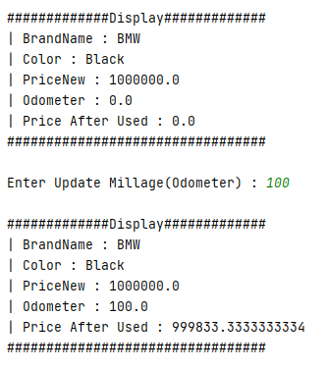 Task No: 4 Write a program to display students name, age, University name and Semester for all 3 students where all students belong to same university and Semester initially. If the student belongs to any other University, then the required method should be called to change his/her University.**

**Solution:**

**Class:**package com.company;  
  
public class Records  
{  
 String Name;  
 String age;  
 static String *Uni*;  
 static String *Semester*;  
 public void setn(String Name)  
 {  
 this.Name = Name;  
 }  
 public void setAge(String age)  
 {  
 this.age = age;  
 }  
 public void setUni(String uni)  
 {  
 this.*Uni* = uni;  
 }  
 public void setSemester(String semester)  
 {  
 this.*Semester* = semester;  
 }  
 public void change()  
 {  
 *Uni* = "Nust";  
 }  
 public void Display()  
 {  
 System.*out*.println("\n#############Display#############");  
 System.*out*.println("Name : " + Name);  
 System.*out*.println("Age : " + age);  
 System.*out*.println("University : " + *Uni*);  
 System.*out*.println("Semester : " + *Semester*);  
 System.*out*.println("#################################");  
 }  
  
}

**Main:**package com.company;  
import javax.lang.model.element.Name;  
import java.util.Locale;  
import java.util.Scanner;  
public class Main  
{  
  
 public static void main(String[] args)  
 {  
 Scanner input = new Scanner(System.*in*);  
 Records obj = new Records();  
 Records obj1 = new Records();  
 Records obj2 = new Records();  
 obj.setn("Muaz");  
 obj1.setn("Talha");  
 obj2.setn("Shahab");  
 obj.setAge("18");  
 obj1.setAge("19");  
 obj2.setAge("20");  
 obj.setSemester("2");  
 obj.setUni("Bahria");  
 obj.Display();  
 obj1.Display();  
 obj2.Display();  
 System.*out*.print("\nYou Want To Change University?? (Y/N) : ");  
 char optn = input.next().toUpperCase().charAt(0);  
 switch (optn)  
 {  
 case 'Y':  
 obj.change();  
 obj.Display();  
 obj1.Display();  
 obj2.Display();  
 case 'N':  
 System.*out*.println("\n Good Bye... ");  
 System.*exit*(0);  
 default:  
 System.*out*.println("Invalid Input");  
 }  
  
 }  
}

**Output:**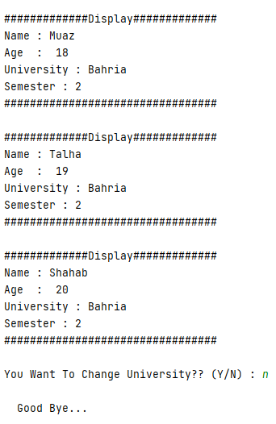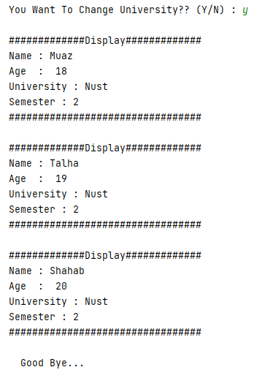

Bahria University,

Karachi Campus



LAB EXPERIMENT NO.

04

LIST OF TASKS

|  |  |
| --- | --- |
| TASK NO | OBJECTIVE |
| 01 | Write a program using the concepts of a default constructor. Consider a computer system whose name, type, processor specification, ram, hard disk drives, mother board, optical drive etc, in a constructor, desired values are entered by the user in a get method (that takes information from the user) and the displays the inputted information via display method. The user shall be asked to change any of the provided information if he/she agrees to change the information then new values shall be asked from the user. |
| 02 | Design then implements a class to represent a **Flight**. A Flight has a *flight number*, a *source*,*destination* and a *number of available seats. This* should be implemented using proper access modifier. The class should have:   1. A **constructor** to initialize the 4 instance variables. You have to shorten the name of the source and the destination to 3 characters only if it is longer than 3 characters by a call to the method in the ‘h’ part. 2. An **overloaded constructor** to initialize the *flight number* and the *number of available seats* instance variables only.   (**NOTE:** Initialize the *source* and the *destination* instance variables to empty string, i.e." ")   1. An **overloaded constructor** to initialize the *flight number* instance variable only.   (**NOTE:** Initialize the *source* and the *destination* instance variables to empty string; and the *number of available seats* to zero)   1. A **method** **public void reserve(int numberOfSeats)** to reserve seats on the flight. (**NOTE:** You have to check that there is enough number of seats to reserve) 2. A **method** **public void cancel(int numberOfSeats)** to cancel one or more reservations 3. A **toString** method to easily return the flight information as follows:   **Flight No: 1234**  **From: KAR**  **To: LAH**  **Available Seats: 18**   1. An **equals** method to compare 2 flights.   (**NOTE:** 2 Flights considered being equal if they have the same flight number)   1. The following method:   **private String shortAndCapital (String name) {**  **if (name.length() <= 3) {**  **return name.toUpperCase();**  **} else {**  **return name.substring(0,3).toUpperCase();**  **}**  **}** |
| 03 | My Java Coffee Outlet runs a catalog business. It sells only one type of coffee beans. The company sells the coffee in 2-lb bags only and the price of a single 2-lb bag is $5.50. when a customer places an order, the company ships the order in boxes. The boxes come in 3 sizes with 3 different costs:   |  |  |  |  | | --- | --- | --- | --- | |  | Large box | Medium box | Small box | | capacity | 20 bags | 10 bags | 5 bags | | cost | $1.80 | $1.00 | $0.60 |   The order is shipped using the least number boxes. For example, the order of 52 bags will be shipped in 2 boxes: 2 large boxes, 1medium and 1 small.  Develop an application that computes the total cost of an order. |

**Task 1: Write a program using the concepts of a default constructor. Consider a computer system whose name, type, processor specification, ram, hard disk drives, mother board, optical drive etc, in a constructor, desired values are entered by the user in a get method (that takes information from the user) and the displays the inputted information via display method. The user shall be asked to change any of the provided information if he/she agrees to change the information then new values shall be asked from the user.  
  
Solution:  
CompSpec Class:**package com.company;  
import java.util.Scanner;  
public class CompSpec  
{  
 private String name;  
 private String processor;  
 private String Harddisk;  
 private String Generation;  
 private String Ram;  
 public void setn(String name)  
 {  
 this.name = name;  
 }  
 public void setp(String processor)  
 {  
 this.processor = processor;  
 }  
 public void seth(String Harddisk)  
 {  
 this.Harddisk = Harddisk;  
 }  
 public void setg(String Generation)  
 {  
 this.Generation = Generation;  
 }  
 public void setr(String Ram)  
 {  
 this.Ram = Ram;  
 }  
 CompSpec()  
 {  
 Scanner input = new Scanner(System.*in*);  
 System.*out*.print("Enter PC Name : ");  
 name = input.next();  
 System.*out*.print("Enter Processor : ");  
 processor = input.next();  
 System.*out*.print("Enter HardDisk : ");  
 Harddisk = input.next();  
 System.*out*.print("Enter Generation : ");  
 Generation = input.next();  
 System.*out*.print("Enter Ram : ");  
 Ram = input.next();  
 }  
 public void display()  
 {  
 System.*out*.println("\n#############Display#############");  
 System.*out*.println("| Name : " + name);  
 System.*out*.println("| Processor : " + processor);  
 System.*out*.println("| HardDisk : " + Harddisk);  
 System.*out*.println("| Generation : " + Generation);  
 System.*out*.println("| Ram : " + Ram);  
 System.*out*.println("#################################");  
 }  
 public void update() {  
 Scanner input = new Scanner(System.*in*);  
 System.*out*.println("\n############Update Menu############");  
 System.*out*.println("Press 1 For Update Name");  
 System.*out*.println("Press 2 For Update Processor");  
 System.*out*.println("Press 3 For Update Ram");  
 System.*out*.println("Press 4 For Update Generation");  
 System.*out*.println("Press 5 For Update HardDisk");  
 System.*out*.println("#################################");  
 System.*out*.print("\nSelect One : ");  
 int a = input.nextInt();  
 switch (a) {  
 case 1:  
 System.*out*.print("Enter Name : ");  
 setn(input.next());  
 break;  
 case 2:  
 System.*out*.print("Enter Processor : ");  
 setp(input.next());  
 break;  
 case 3:  
 System.*out*.print("Enter Ram : ");  
 setr(input.next());  
 break;  
 case 4:  
 System.*out*.print("Enter Generation : ");  
 setg(input.next());  
 break;  
 case 5:  
 System.*out*.print("Enter HardDisk : ");  
 seth(input.next());  
 break;  
 default:  
 System.*out*.print("Please Enter Valid Input...");  
 break;  
 }  
 }  
}

**Main Class:**package com.company;  
  
import java.util.Scanner;  
  
public class Main  
{  
  
 public static void main(String[] args)  
 {  
 Scanner input = new Scanner(System.*in*);  
 CompSpec obj = new CompSpec();  
 boolean t = true;  
 while (t)  
 {  
 obj.display();  
 System.*out*.print("\nYou Want To Update Any Inforamtion??? (Y/N) : ");  
 char optn = input.next().toUpperCase().charAt(0);  
 switch (optn)  
 {  
 case 'Y':  
 obj.update();  
 break;  
 case 'N':  
 System.*out*.print("\nYou Want To Exit From Program???(Y/N) : ");  
 char choice = input.next().toUpperCase().charAt(0);  
 if(choice == 'Y')  
 {  
 System.*out*.println("\n Good Bye...!!! ");  
 System.*exit*(0);  
 }  
 else {  
 t = true;  
 }  
 break;  
 default:  
 System.*out*.println("Please Enter Valid Input....");  
 t = true;  
  
 }  
  
 }  
  
  
  
 }  
  
}

**Output: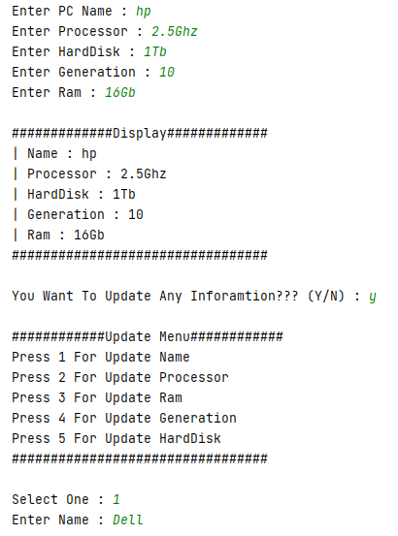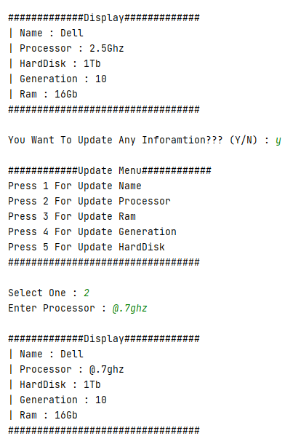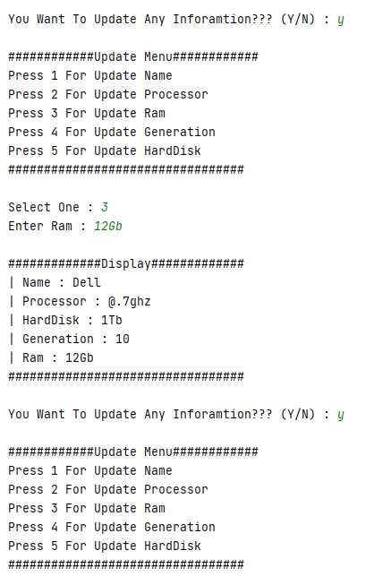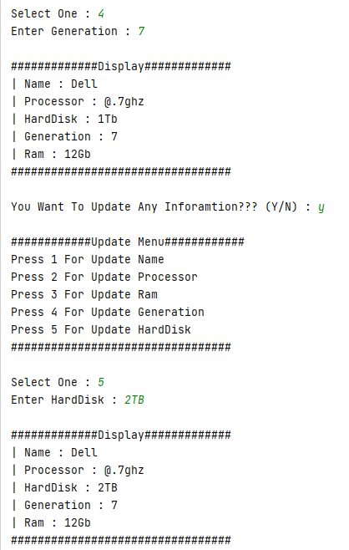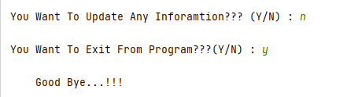 Task 2:** Design then implement a class to represent a **Flight**. A Flight has a *flight number*, a *source*, a *destination* and a *number of available seats. This* should be implemented using proper access modifier. The class should have:

1. A **constructor** to initialize the 4 instance variables. You have to shorten the name of the source and the destination to 3 characters only if it is longer than 3 characters by a call to the method in the ‘h’ part.
2. An **overloaded constructor** to initialize the *flight number* and the *number of available seats* instance variables only.

(**NOTE:** Initialize the *source* and the *destination* instance variables to empty string, i.e." ")

1. An **overloaded constructor** to initialize the *flight number* instance variable only.

(**NOTE:** Initialize the *source* and the *destination* instance variables to empty string; and the *number of available seats* to zero)

1. A **method** **public void reserve(int numberOfSeats)** to reserve seats on the flight. (**NOTE:** You have to check that there is enough number of seats to reserve)
2. A **method** **public void cancel(int numberOfSeats)** to cancel one or more reservations
3. A **toString** method to easily return the flight information as follows:

**Flight No: 1234**

**From: KAR**

**To: LAH**

**Available Seats: 18**

1. An **equals** method to compare 2 flights.

(**NOTE:** 2 Flights considered being equal if they have the same flight number)

1. The following method:

**private String shortAndCapital (String name) {**

**if (name.length() <= 3) {**

**return name.toUpperCase();**

**} else {**

**return name.substring(0,3).toUpperCase();**

**}**

**}**

**Solution:  
Reservation Class:**package com.company;  
import java.util.Scanner;  
public class Reservation  
{  
 Scanner s=new Scanner(System.*in*);  
 private int FlightNo;  
 private String Source;  
 private String Destination;  
 private int Seat;  
 Reservation()  
 {  
 FlightNo=123;  
 Seat=100;  
 Source="KHI";  
 Destination="ISL";  
 display();  
 }  
 Reservation(int FlightNo,int Seat,String Source,String Destination)  
 {  
 this.FlightNo=FlightNo;  
 this.Seat=Seat;  
 this.Source=shortlong(Source);  
 this.Destination=shortlong(Destination);  
 }  
 Reservation(int FlightNo,int n)  
 {  
 this.FlightNo=FlightNo;  
 this.Seat=n;  
 this.Destination="";  
 this.Source="";  
 }  
 Reservation(int FlightNo)  
 {  
 this.FlightNo=FlightNo;  
 this.Seat=0;  
 this.Destination="";  
 this.Source="";  
 }  
 public String shortlong(String a)  
 {  
 if(a.length()<=3)  
 {  
 return a.toUpperCase();  
 }  
 else{  
 return a.substring(0, 3).toUpperCase();  
 }  
 }  
 public void reverse(int seat){  
 if(seat<=Seat)  
 {  
 System.*out*.println("Seat Reserved");  
 }  
 else  
 {  
 System.*out*.println("Sorry No Seat Available");  
 seat-=Seat;  
 }  
 }  
 public void cancel(int seat)  
 {  
 Seat+=seat;  
 System.*out*.println("Seat Cancel");  
 }  
 public void equals(int a,int b)  
 {  
 if(a==b)  
 {  
 System.*out*.println("Flight Number Are Same ");  
 }  
 else  
 {  
 System.*out*.println("Flight Number Are Not Same ");  
 }  
 }  
 public void display()  
 { System.*out*.println("\n#############Display#############");  
 System.*out*.println("Flight No : " +FlightNo);  
 System.*out*.println("Source : " +Source);  
 System.*out*.println("Destination : " +Destination);  
 System.*out*.println("Avaliable Seat : " + Seat);  
 System.*out*.println("#################################");  
 }  
  
}

**Main Class:**package com.company;  
import java.util.Scanner;  
public class Main {  
  
 public static void main(String[] args)  
 {  
 Scanner input = new Scanner(System.*in*);  
 int num,seats;  
 String source,dest;  
 Reservation obj=new Reservation(1234,100,"Karachi","Islamabad");  
 Reservation obj1=new Reservation();  
 System.*out*.print("Do You Want To Changing In Flight (Y/N) : ");  
 char optn =input.next().toUpperCase().charAt(0);  
 if (optn=='Y')  
 {  
 do {  
 System.*out*.println("\n########Flight Updation#########");  
 System.*out*.println("Press 1 For Enter Flight No,Source,Destination,Avaliable Seats");  
 System.*out*.println("Press 2 For Enter Flight No,Avaliable Seats");  
 System.*out*.println("Press 3 For Enter Flight No");  
 System.*out*.println("Press 4 For Reserve Seats");  
 System.*out*.println("Press 5 For Cancel Seats");  
 System.*out*.print("Select Option : " );  
 int choice=input.nextInt();  
 switch (choice){  
 case 1:  
 System.*out*.print("Enter Flight Number : ");  
 num=input.nextInt();  
 System.*out*.print("Enter Source : ");  
 source=obj1.shortlong(input.next());  
 System.*out*.print("Enter Destination : ");  
 dest=obj1.shortlong(input.next());  
 System.*out*.print("Enter Avaliable Seats : ");  
 seats=input.nextInt();  
 obj1=new Reservation(num,seats,source,dest);  
 break;  
 case 2:  
 System.*out*.print("Enter Flight Number : ");  
 num=input.nextInt();  
 System.*out*.print("Enter Avaliable Seats : ");  
 seats=input.nextInt();  
 obj1=new Reservation(num,seats);  
 break;  
 case 3:  
 System.*out*.print("Enter Flight Number : " );  
 num=input.nextInt();  
 obj1=new Reservation(num);  
 break;  
 case 4:  
 System.*out*.println("Which Seat Do You Want To Reserve");  
 num=input.nextInt();  
 obj1.reverse(num);  
 break;  
 case 5:  
 System.*out*.println("Which Seat Do You Want To Cancel");  
 num=input.nextInt();  
 obj1.cancel(num);  
 break;  
 default:  
 System.*out*.println("Invalid Input....");  
  
 }  
 System.*out*.print("You Want To Again Changing (Y/N) : " );  
 optn=input.next().toUpperCase().charAt(0);  
 } while (optn=='Y');  
 }  
 System.*out*.print("You Want To Compare Flights (Y/N) : ");  
 optn=input.next().toUpperCase().charAt(0);  
 if(optn=='Y')  
 {  
 System.*out*.println("Enter Flight No 1");  
 int a=input.nextInt();  
 System.*out*.println("Enter Flight No 2");  
 int b=input.nextInt();  
 obj1.equals(a,b);  
 }  
 System.*out*.println("\nFlight 1");  
 obj.display();  
 System.*out*.println("\nFlight 2");  
 obj1.display();  
  
  
 }  
}

**Output:**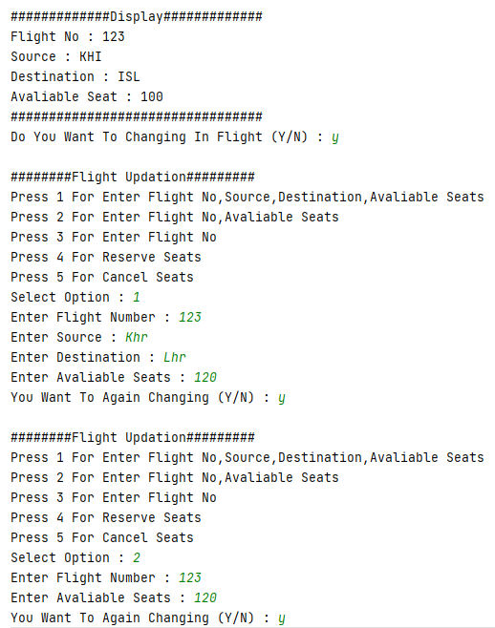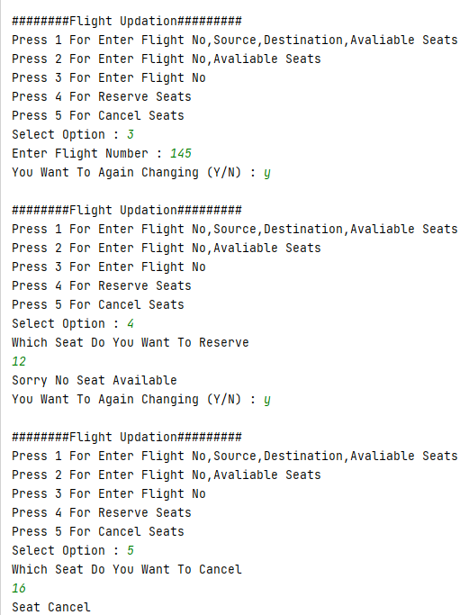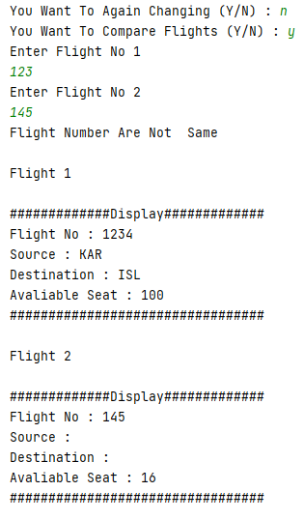

**Task 3:**

|  |  |  |  |  |  |  |  |  |  |  |  |  |
| --- | --- | --- | --- | --- | --- | --- | --- | --- | --- | --- | --- | --- |
| MyJava Coffee Outlet runs a catalog business. It sells only one type of coffee beans. The company sells the coffee in 2-lb bags only and the price of a single 2-lb bag is $5.50. when a customer places an order, the company ships the order in boxes. The boxes come in 3 sizes with 3 different costs:   |  |  |  |  | | --- | --- | --- | --- | |  | Large box | Medium box | Small box | | capacity | 20 bags | 10 bags | 5 bags | | cost | $1.80 | $1.00 | $0.60 |   The order is shipped using the least number boxes. For example, the order of 52 bags will be shipped in 2 boxes: 2 large boxes, 1medium and 1 small.  Develop an application that computes the total cost of an order. |

**Solution:  
Coffee Class:**package com.company;  
import java.util.Scanner;  
public class Coffeee  
{  
 int Bags;  
 double Cost, TC;  
 final double LBP = 1.80;  
 final double MBP = 1.00;  
 final double SBP = 0.60;  
 final double OC = 5.50;  
 int LargeBox;  
 int MediumBox;  
 int SmallBox = 0;  
 public void Calculations()  
 {  
 Scanner user = new Scanner(System.*in*);  
 System.*out*.println("\n########Coffee Beans#######");  
 System.*out*.print("\nEnter Bags You Want To Order : ");  
 Bags = user.nextInt();  
 Cost = Bags * OC;  
 LargeBox = Bags / 20;  
 MediumBox = (Bags % 20) / 10;  
 SmallBox = 0;  
 if (Bags % 10 <= 5 && Bags % 10 > 0) {  
 SmallBox = 1;  
 } else if (Bags % 10 > 5) {  
 SmallBox = 2;  
 } else {  
 SmallBox = 0;  
 }  
 }  
 public void display() {  
 System.*out*.println("\n#############Display#############");  
 System.*out*.println("Bags Order : " + Bags);  
 System.*out*.println("Cost Of Order : $" + Cost);  
 System.*out*.println("Boxes Used ");  
 System.*out*.println(LargeBox + " Large Box == $"+LargeBox * LBP);  
 System.*out*.println(MediumBox +" MediumBox == $"+MediumBox * MBP);  
 System.*out*.println(SmallBox + " Small Box == $"+SmallBox * SBP);  
 TC = Cost + (LargeBox * LBP) + (MediumBox * MBP) + (SmallBox * SBP);  
 System.*out*.println("\n################################");  
 System.*out*.println("Total Cost : $"+TC);  
 System.*out*.println("################################");  
 }  
}

**Main Class:**package com.company;  
  
public class Main {  
  
 public static void main(String[] args)  
 {  
 Coffeee object = new Coffeee();  
 object.Calculations();  
 object.display();  
 }  
}

**Output:**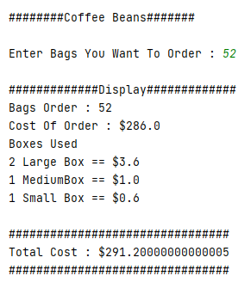

Bahria University,

Karachi Campus



LAB EXPERIMENT NO.

**05**

LIST OF TASKS

|  |  |
| --- | --- |
| TASK NO | OBJECTIVE |
| 01 | Write a program to calculate area of rectangle by using static method. Use parameterized constructor to assign width and height to the instance. Use Output area method which uses the static method to calculate the area. |
| 02 | Write a program to display Name, Enrollment Number, University Name and, Semester of students that are from same university and semester using static fields and methods.(Hint: first set the university name and semester as follows:    Then use static variable counter to get unique roll numbers as follows: |
| 03 | Write a static method called print Times that takes an integer n and a string (in that order) as its parameters and prints the string n times. For example |
| 04 | Write a static method called insult that has two parameters, a String which represents a person’s name and an integer which represents the persons age. This method should create and **return** a String which is a personal insult based on the value of the argument age that was passed. Use the following age cutoffs (or variations of your choosing) for creating your insults: |
| 05 | Write a static method called greet Me that greets you. The method should issue a prompt asking for your name, display a polite (or not so polite) greeting message and then prompt you to enter your age. |

**Task No: 1 Write a program to calculate area of rectangle by using static method. Use parameterized constructor to assign width and height to the instance. Use Output area method which uses the static method to calculate the area.**

**Solution:**

**Class:**

public class Area  
{  
 static int *width*;  
 static int *height*;  
 static int *ans*;  
 Area(int h,int w)  
 {  
 *height* = h;  
 *width* =w;  
 }  
 static void rectangle()  
 {  
 *ans* = *width*\**height*;  
 }  
 void display()  
 {  
 System.*out*.println("\nArea Of Rectangle : " + *ans*);  
 }  
}

**Main:**

public class Main {  
  
 public static void main(String[] args) {  
 Area obj = new Area(15,30);  
 Area.*rectangle*();  
 obj.display();  
 }  
}

**Output:**

**Task No: 2 Write a program to display Name, Enrollment Number, University Name and, Semester of students that are from same university and semester using static fields and methods.(Hint: first set the university name and semester as follows:**



**Then use static variable counter to get unique roll numbers as follows:**

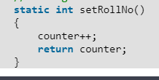

**Solution:  
Class:**package com.company;  
import java.util.Scanner;  
public class StndsRecord  
{  
 static String *Name*;  
 static String *enrollmentNo*;  
 static int *counter*;  
 static String *University* = "Bahria";  
 static String *Semester* = "2";  
 static void setdata()  
 {  
 Scanner input = new Scanner(System.*in*);  
 System.*out*.print("Enter Name : ");  
 *Name* = input.next();  
 System.*out*.print("Enter Enrollment : ");  
 *enrollmentNo* = input.next();  
  
 }  
 static int setroll()  
 {  
 *counter*++;  
 return *counter*;  
 }  
 static void Display()  
 {  
 System.*out*.println("\n#############Display#############");  
 System.*out*.println("Roll : " + *counter*);  
 System.*out*.println("Name : " + *Name*);  
 System.*out*.println("Enrollment No : " + *enrollmentNo*);  
 System.*out*.println("University : " + *University*);  
 System.*out*.println("Semester : " + *Semester*);  
 System.*out*.println("#################################");  
 }  
  
}

**Main:**public class Main {  
  
 public static void main(String[] args)  
 {  
 for (int i=0;i<3;i++)  
 {  
 StndsRecord.*setdata*();  
 StndsRecord.*setroll*();  
 StndsRecord.*Display*();  
  
 }  
 }  
}

**Output:**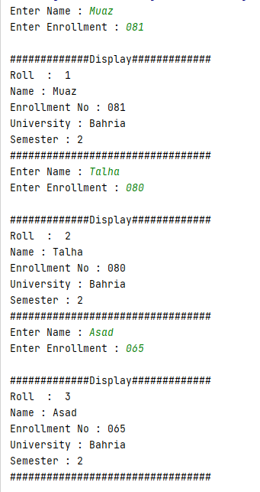

**Task No: 3 Write a static method called print Times that takes an integer n and a string (in that order) as its parameters and prints the string n times. For example**

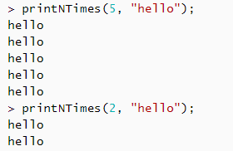

**Solution:**

**Class:**

package com.company;  
import java.util.Scanner;  
public class Myclass  
{  
  
 static void PrintN(int a,String m)  
 {  
 Scanner input = new Scanner(System.*in*);  
 for(int j=0;j<a;j++)  
 {  
 System.*out*.println(m);  
 }  
 }  
}

**Main:**

public class Main {  
  
 public static void main(String[] args) {  
 Myclass.*PrintN*(6,"muaz");  
 }  
}

**Output:**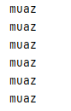

**Task No: 4 Write a static method called insult that has two parameters, a String which represents a person’s name and an integer which represents the persons age. This  
method should create and return a String which is a personal insult based on the value of the argument age that was passed. Use the following age cutoffs (or variations of your choosing) for creating your insults:  
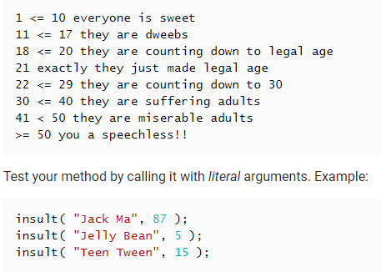**

**Solution:**

**Class:**

package com.company;  
  
public class New  
{  
 static String insult(String name,int age)  
 {  
 String a;  
 if(age>=1 && age<= 10) {  
  
 a="Everyone Is Sweet";  
 }  
 else if(age>=11 && age<= 17) {  
  
 a="They Are Dweebs";  
 }  
 else if(age>=18 && age<= 20) {  
  
 a="They Are Counting Down To Legal Age";  
 }  
 else if(age==21){  
  
 a="Exactly They Just Made Legal Age";  
 }  
 else if(age>=22 &&age<= 29) {  
  
 a="They Are Counting Down To 30";  
 }  
 else if(age>=30 && age<= 40) {  
  
 a="They Are Suffering Adults";  
 }  
 else if(age>=41 && age<= 50) {  
  
 a="They Are Miserable Adults";  
 }  
 else if(age>= 50) {  
  
 a="You A Speechless!!";  
 }  
 else{  
 a="";  
 }  
 return a;  
 }  
  
}

**Main:**package com.company;  
public class Main {  
  
 public static void main(String[] args) {  
  
 System.*out*.println(New.*insult*("Asad", 87) );  
 System.*out*.println(New.*insult*("Ali",5) );  
 System.*out*.println(New.*insult*("Kashif",15) );  
 System.*out*.println(New.*insult*("Hamza",25) );  
 System.*out*.println(New.*insult*("Awais",32) );  
  
 }  
}

**Output:**

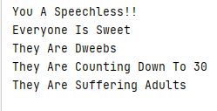

**Task No: 5 Write a static method called greet Me that greets you. The method should issue a prompt asking for your name, display a polite (or not so polite) greeting message and then prompt you to enter your age.**

**Solution:  
Class:**package com.company;  
  
public class Greet  
{  
 static void greet(String name)  
 {  
 System.*out*.println("\nWelcome Mr " + name);  
 }  
  
}

**Main:**package com.company;  
import java.util.Scanner;  
public class Main {  
  
 public static void main(String[] args)  
 {  
 Scanner input = new Scanner (System.*in*);  
 System.*out*.print("Enter your Name : ");  
 String name=input.nextLine();  
 Greet.*greet*(name);  
 System.*out*.print("\nEnter your Age : ");  
 int age=input.nextInt();  
  
 }  
}

**Output:**

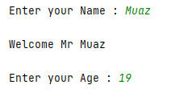  
  
  
  
  
  
Bahria University,

Karachi Campus



LAB EXPERIMENT NO.

06

LIST OF TASKS

|  |  |
| --- | --- |
| TASK NO | OBJECTIVE |
| 01 | Write a program which contains a class ‘Calculator’ contains multiple sum method by using method overloading concept. |
| 02 | Create a class to print the area of a square and a rectangle. The class has two methods with the same name but different number of parameters. The method for printing area of rectangle has two parameters which are length and breadth respectively while the other method for printing area of square has one parameter which is side of square. |
| 03 | Create a class 'Student' with three data members which are name, age and address. The constructor of the class assigns default values name as "unknown", age as '0' and address as "not available". It has two members with the same name 'setInfo'. First method has two parameters for name and age and assigns the same whereas the second method takes has three parameters which are assigned to name, age and address respectively. Print the name, age and address of 4 students. |
| 04 | Implement the Circle class to overload the + operator so that you can add two Circle objects. Adding two Circle object should give another Circle whose radius is the sum of the radii of the two Circle objects. |
| 05 | Implement the Rectangle class to overload the + operator so that you can add two Rectangle objects. Adding two Rectangle objects should give another Rectangle object whose length is the sum of the lengths of the two Rectangle objects and whose breadth is the sum of the breadths of the two Rectangle objects. |
| 06 | Write a class Time which represents time. the class should have three fields for hours, minutes and seconds. It should have constructor to initialize the hours, minutes and seconds. A method printTime() to print the current time. Overload the following operators: plus operator (+) (add two time objects based on 24 hour clock) and < (compare two time objects) |

**Task No: 1** Write a program which contains a class ‘Calculator’ contains multiple sum method by using method overloading concept.

**Solution:  
Class:**package com.company;  
  
public class calculator  
{  
 static double *result*;  
 static void sum(int a,int b)  
 {  
 *result* = (a+b);  
 System.*out*.println("Result : " + *result*);  
 }  
 static void sum(int a,int b,int c)  
 {  
 *result* = (a+b+c);  
 System.*out*.println("Result : " + *result*);  
 }  
 static void sum(int a,int b,int c,int d)  
 {  
 *result* = (a+b+c+d);  
 System.*out*.println("Result : " + *result*);  
 }  
 static void sum(int a,int b,int c,int d,int e)  
 {  
 *result* = (a+b+c+d+e);  
 System.*out*.println("Result : " + *result*);  
 }  
 static void sum(int a,int b,int c,int d,int e,int f)  
 {  
 *result* = (a+b+c+d+e+f);  
 System.*out*.println("Result : " + *result*);  
 }  
}

**Main:**package com.company;  
  
public class Main {  
  
 public static void main(String[] args)  
 {  
 calculator.*sum*(2,2);  
 calculator.*sum*(2,3,4);  
 calculator.*sum*(2,3,4,5);  
 calculator.*sum*(2,3,4,5,6);  
 calculator.*sum*(2,3,4,5,6,2);  
  
  
 }  
}

**Output:**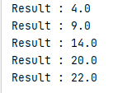

**Task No: 2** Create a class to print the area of a square and a rectangle. The class has two methods with the same name but different number of parameters. The method for printing area of rectangle has two parameters which are length and breadth respectively while the other method for printing area of square has one parameter which is side of square.

**Solution:  
Class:**package com.company;  
  
public class newclass  
{  
 static double *result*;  
 static void area(int length,int breath)  
 {  
 *result* = length*breath;  
 System.*out*.println("Area Of Rectangle : " + *result*);  
 }  
 static void area(int sides)  
 {  
 *result* = sides*sides;  
 System.*out*.println("Area Of Square : " + *result*);  
 }  
}

**Main:**package com.company;  
  
public class Main {  
  
 public static void main(String[] args)  
 {  
 newclass.*area*(4,2);  
 newclass.*area*(4);  
 }  
}

**Output:**

**Task No: 3** Create a class 'Student' with three data members which are name, age and address. The constructor of the class assigns default values name as "unknown", age as '0' and address as "not available". It has two members with the same name 'setInfo'. First method has two parameters for name and age and assigns the same whereas the second method takes has three parameters which are assigned to name, age and address respectively. Print the name, age and address of 4 students.

**Solution:  
Class:**package com.company;  
  
public class Students  
{  
 String Name;  
 int Age;  
 String Address;  
 Students()  
 {  
 Name = "Unknown";  
 Age = 0;  
 Address = "Not Available";  
 System.*out*.println("\nName : " + Name);  
 System.*out*.println("Age : " + Age);  
 System.*out*.println("Address : " + Address);  
  
 }  
 static void setinfo(String Name,int Age)  
 {  
 System.*out*.println("\nName : " + Name);  
 System.*out*.println("Age : " + Age);  
 }  
 static void setinfo(String Name,int Age,String Address)  
 {  
 System.*out*.println("\nName : " + Name);  
 System.*out*.println("Age : " + Age);  
 System.*out*.println("Address : " + Address);  
 }  
}

**Main:**package com.company;  
  
public class Main {  
  
 public static void main(String[] args)  
 {  
 Students obj = new Students();  
 System.*out*.println("\n######Students Record#####");  
 Students.*setinfo*("Talha",20);  
 Students.*setinfo*("Awais",19);  
 Students.*setinfo*("Asad",18);  
 Students.*setinfo*("Hassan",21);  
 System.*out*.println("\n######Students Record#####");  
 Students.*setinfo*("Talha",20,"Karsaz");  
 Students.*setinfo*("Awais",19,"Saddar");  
 Students.*setinfo*("Asad",18,"Malir");  
 Students.*setinfo*("Hassan",21,"Dalmia");  
  
 }  
}

**Output:**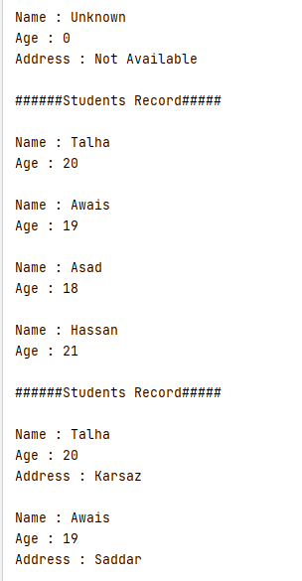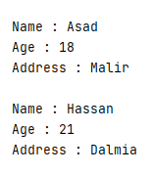

**Task No: 4** Implement the Circle class to overload the + operator so that you can add two Circle objects. Adding two Circle object should give another Circle whose radius is the sum of the radii of the two Circle objects.

**Solution:  
Class:**namespace Circleoperatoroverloading_L6_T4

{

class Circle

{

int diameter;

double result;

public Circle()

{

this.diameter = 0;

}

public Circle(int diameter)

{

this.diameter = diameter;

}

public double get()

{

result = diameter / 2;

return result;

}

public static Circle operator +(Circle c1,Circle c2)

{

Circle c3 = new Circle();

c3.diameter = c1.diameter + c2.diameter;

return c3;

}

}

}

**Main:**namespace Circleoperatoroverloading_L6_T4

{

class Program

{

static void Main(string[] args)

{

Circle obj1 = new Circle(10);

Circle obj2 = new Circle(12);

Circle obj3 = obj1 + obj2;

Console.WriteLine("\nRadius of Circle1 : " + obj1.get());

Console.WriteLine("Radius of Circle2 : " + obj2.get());

Console.WriteLine("\n------------------------------");

Console.WriteLine("\nAdd Two Circle Radius");

Console.WriteLine("\nRadius of Circle3 : " + obj3.get());

Console.ReadKey();

}

}

}

**Output:**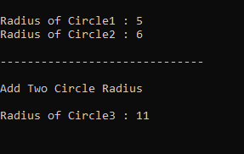

**Task No: 5** Implement the Rectangle class to overload the + operator so that you can add two Rectangle objects. Adding two Rectangle objects should give another Rectangle object whose length is the sum of the lengths of the two Rectangle objects and whose breadth is the sum of the breadths of the two Rectangle objects.

**Solution:  
Class:**namespace overloading

{

class Rec

{

public int length;

public int breath;

public double result;

public Rec()

{

this.length = 0;

this.breath = 0;

}

public Rec(int length, int breath)

{

this.length = length;

this.breath = breath;

}

public double get()

{

result = length * breath;

return result;

}

public static Rec operator +(Rec obj1,Rec obj2)

{

Rec obj3 = new Rec();

obj3.length = obj1.length + obj2.length;

obj3.breath = obj1.breath + obj2.breath;

return obj3;

}

}

}

**Main:**namespace overloading

{

class Program

{

static void Main(string[] args)

{

Rec obj1 = new Rec(2, 4);

Rec obj2 = new Rec(4, 4);

Rec obj3 = new Rec();

obj3 = obj1 + obj2;

Console.WriteLine("\n#######RECTANGLE 1#######");

Console.WriteLine("\nLength : " + obj1.length);

Console.WriteLine("Breath : " + obj1.breath);

Console.WriteLine("Area Of Rectangle1 : " + obj1.get());

Console.WriteLine("\n#######RECTANGLE 2#######");

Console.WriteLine("\nLength : " + obj2.length);

Console.WriteLine("Breath : " + obj2.breath);

Console.WriteLine("Area Of Rectangle2 : " + obj2.get());

Console.WriteLine("\n#######RECTANGLE 3#######");

Console.WriteLine("Sum Of Rectangle1 & Rectangle2 ");

Console.WriteLine("\nLength : " + obj3.length);

Console.WriteLine("Breath : " + obj3.breath);

Console.WriteLine("Area Of Rectangle : " + obj3.get());

Console.ReadKey();

}

}

}

**Output:**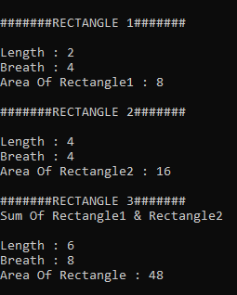

**Task No: 6** Write a class Time which represents time. the class should have three fields for hours, minutes and seconds. It should have constructor to initialize the hours, minutes and seconds.  
A method printTime() to print the current time.  
Overload the following operators:  
plus operator (+) (add two time objects based on 24 hour clock)  
and < (compare two time objects)

**Solution:  
Class:**namespace Time_overloading_L6_T6

{

class Time

{

public int hours;

public int minutes;

public int seconds;

public Time()

{

this.hours = 0;

this.minutes = 0;

this.seconds = 0;

}

public Time(int hours,int minutes,int seconds)

{

this.hours = hours;

this.minutes = minutes;

this.seconds = seconds;

}

public static Time operator +(Time t1, Time t2)

{

Time t3 = new Time();

t3.hours = t1.hours + t2.hours;

t3.minutes = t1.minutes + t2.minutes;

t3.seconds = t1.seconds + t2.seconds;

return t3;

}

public static bool operator <(Time t1, Time t2)

{

bool ans;

if (t1.hours < t2.hours && t1.minutes < t2.minutes && t1.seconds < t2.seconds)

{

ans = true;

}

else

{

ans = false;

}

return ans;

}

public static bool operator >(Time t1, Time t2)

{

bool ans;

if (t1.hours > t2.hours && t1.minutes > t2.minutes && t1.seconds > t2.seconds)

{

ans = true;

}

else

{

ans = false;

}

return ans;

}

}

}

**Main:**namespace Time_overloading_L6_T6

{

class Program

{

static void Main(string[] args)

{

Time t1 = new Time(2, 2, 2);

Time t2 = new Time(3, 3, 3);

Time t3 = new Time();

t3 = t1 + t2;

Console.WriteLine("\n#####Time 1######");

Console.WriteLine("\nHours : " + t1.hours);

Console.WriteLine("Minutes : " + t1.minutes);

Console.WriteLine("Seconds : " + t1.seconds);

Console.WriteLine("\n#####Time 2######");

Console.WriteLine("\nHours : " + t2.hours);

Console.WriteLine("Minutes : " + t2.minutes);

Console.WriteLine("Seconds : " + t2.seconds);

Console.WriteLine("\n#####Time 3######");

Console.WriteLine("ADD TIME1 & TIME2");

Console.WriteLine("\nHours : " + t3.hours);

Console.WriteLine("Minutes : " + t3.minutes);

Console.WriteLine("Seconds : " + t3.seconds);

Console.WriteLine("-------------------------------");

Console.WriteLine("\nTime1 Greater : {0}", t1 > t2);

Console.WriteLine("Time2 Greater : {0}", t1 < t2);

}

}

}

**Output:**